UNITED STATES
SECURITIES AND EXCHANGE COMMISSION
Washington, D.C. 20549

FORM 8-K

CURRENT REPORT
Pursuant to Section 13 or 15(d)
of the Securities Exchange Act of 1934

Date of Report (Date of earliest event reported): September 8, 2026

Structure Therapeutics Inc.
(Exact name of registrant as specified in its charter)

Cayman Islands |  | 001-41608 |  | 98-1480821
(State or other jurisdiction  of incorporation) |  | (Commission  File Number) |  | (IRS Employer  Identification No.)

601 Gateway Blvd., Suite 900  South San Francisco, California |  | 94080
(Address of principal executive offices) |  | (Zip Code)

(Registrant’s telephone number, including area code): (650) 457-1978

Not Applicable
(Former name or former address, if changed since last report)

Check the appropriate box below if the Form 8-K filing is intended to simultaneously satisfy the filing obligation of the registrant under any of the following provisions (see General Instruction A.2. below):

☐ | Written communications pursuant to Rule 425 under the Securities Act (17 CFR 230.425)

☐ | Soliciting material pursuant to Rule 14a-12 under the Exchange Act (17 CFR 240.14a-12)

☐ | Pre-commencement communications pursuant to Rule 14d-2(b) under the Exchange Act (17 CFR 240.14d-2(b))

☐ | Pre-commencement communications pursuant to Rule 13e-4(c) under the Exchange Act (17 CFR 240.13e-4(c))

Securities registered pursuant to Section 12(b) of the Act:

Title of Each Class |  | Name Of Each Exchange  Trading Symbol(s) |  | On Which Registered
American Depositary Shares (ADSs), each representing three  ordinary shares, par value $0.0001 per ordinary share |  | GPCR |  | Nasdaq Global Market
Ordinary shares, par value $0.0001 per share* |  | True |  | Nasdaq Global Market*

* Not for trading, but only in connection with the registration of the American Depositary Shares

Indicate by check mark whether the registrant is an emerging growth company as defined in Rule 405 of the Securities Act of 1933 (§230.405 of this chapter) or Rule 12b-2 of the Securities Exchange Act of 1934 (§240.12b-2 of this chapter).

Emerging growth company ☐

If an emerging growth company, indicate by check mark if the registrant has elected not to use the extended transition period for complying with any new or revised financial accounting standards provided pursuant to Section 13(a) of the Exchange Act. ☐

Item 7.01 Regulation FD Disclosure.

On September 8, 2026, Structure Therapeutics Inc. (the Company) issued a press release announcing positive topline clinical trial results across its oral small molecule amylin and GLP-1 programs for chronic weight management, including Phase 1/2a single ascending dose (SAD) results for ACCG-2671 (oral small molecule amylin receptor agonist) and 72-week results from the ACCESS open-label extension (OLE) study of aleniglipron (oral small molecule selective GLP-1 receptor agonist). A copy of the press release is furnished as Exhibit 99.1 to this Current Report on Form 8-K.

On September 8, 2026, the Company made available on its website an investor presentation to be shared with investors and others from time to time. A copy of this presentation is being furnished as Exhibit 99.2 to this Current Report on Form 8-K.

The information set forth in this Item 7.01 and in the press release and investor presentation attached hereto as Exhibits 99.1 and 99.2, respectively, is deemed to be “furnished” and shall not be deemed to be “filed” for purposes of Section 18 of the Securities Exchange Act of 1934, as amended (the Exchange Act), or otherwise subject to the liabilities of that Section. The information set forth in this Item 7.01, including Exhibits 99.1 and 99.2, shall not be deemed incorporated by reference into any filing under the Exchange Act or the Securities Act of 1933, as amended, except to the extent that the Company specifically incorporates it by reference.

Item 8.01 Other Events.

ACCG-2671 (Oral Small Molecule DACRA): Phase 1 SAD Topline Clinical Trial Results

On September 8, 2026, the Company reported positive topline data for ACCG-2671, an oral, non-peptide, small molecule dual amylin and calcitonin receptor agonist (DACRA), from the SAD portion of the Phase 1/2a clinical trial. The SAD portion evaluated the safety, tolerability, pharmacokinetics (PK) and exploratory pharmacodynamic (PD) effects of ACCG-2671 in 31 healthy adult participants without obesity. A wide range of doses were explored in this first-in-human study to, among other things, inform the appropriate starting dose and titration regimen for the multiple ascending dose (MAD) study. Participants received a single dose of 1, 2, 5, or 10 mg of ACCG-2671 or placebo.

In the SAD trial, ACCG-2671 demonstrated a favorable plasma PK profile showing rapid absorption with Tmax at 1 to 1.5 hours. Exposure was consistent with dose proportionality, and the terminal half-life was approximately 6 days supporting further evaluation of daily and weekly dosing.

In the SAD trial, ACCG-2671 was generally well tolerated, with a favorable tolerability profile. There were no serious adverse events, no drug-related treatment-emergent adverse events (TEAEs) leading to treatment discontinuation, and no events of drug-induced liver injury. No nausea or vomiting was reported in the placebo, 1 mg or 2 mg dose cohorts. Dose-related gastrointestinal events emerged at 5 mg, with nausea in 4 of 5 participants and vomiting in 3 of 5 participants, and at 10 mg (in 6 of 6 participants). These findings informed the starting doses and gradual titration strategies currently being evaluated in the ongoing MAD clinical trial.

Exploratory findings with a single dose of ACCG-2671 indicated encouraging and early PD activity. A single 10 mg dose (n=6) was associated with mean body weight reductions of 3.3% at Day 24. In addition, CTX-1, a well-recognized biomarker of bone resorption, decreased by approximately 60% on Day 2 across the active dose cohorts. Together, these findings provide evidence of target engagement and support further evaluation of ACCG-2671 as a potential monotherapy as well as part of combination regimens.

The Company has begun dosing in the MAD portion of the ongoing Phase 1/2a study of ACCG-2671. The randomized, placebo-controlled MAD portion will evaluate the safety, tolerability and PK of multiple ascending oral doses of ACCG-2671 administered for 84 days across five cohorts of participants living with obesity. The clinical trial will evaluate different doses and titration regimens, dosing frequencies, with daily and weekly dosing regimens, and includes a cohort of participants receiving a stable dose of an injectable GLP-1 receptor agonist, providing an initial assessment of ACCG-2671 when administered in combination with a GLP-1 receptor agonist. Topline data for the MAD portion of the Phase 1/2a clinical trial are expected in the first half of 2027.

Aleniglipron (Oral Small Molecule Selective GLP-1 Receptor Agonist): ACCESS OLE Results

The Company also reported positive 72-week results from the ACCESS OLE clinical trial, a prespecified 36-week extension of the Phase 2b ACCESS clinical trial (NCT06693843) designed to evaluate the longer-term safety and tolerability of aleniglipron and the durability of weight loss through 72 weeks of treatment. Approximately 87% of eligible participants who completed the initial 36-week double-blind treatment period in ACCESS entered the OLE. Participants continued once-daily treatment in the OLE trial, with doses titrated every four weeks, while participants originally assigned to placebo crossed over to aleniglipron at Week 36 starting with a lower 2.5 mg dose. The OLE also evaluated whether the lower starting dose improved gastrointestinal tolerability. Since participants were titrated to the highest dose of 180 mg after Week 60, this resulted in relatively limited exposure to the 180 mg dose by Week 72.

Building on previously reported interim results from the ACCESS OLE at 56 weeks in March 2026, aleniglipron demonstrated continued weight reduction at 72 weeks. Participants originally randomized to the 45 mg, 90 mg and 120 mg arms in the ACCESS trial who continued into the OLE and dosed up to 180 mg achieved weight loss of 11.6%, 14.4% and 16.2%, respectively, with no evidence of weight loss plateau in the two top doses. More than one-third of participants in the highest dose cohorts, 90 mg and 120 mg, achieved more than 20% body weight reduction, with mean absolute body weight loss of 35.9 and 40.5 pounds, respectively.

Participants, who were originally assigned to placebo in the ACCESS clinical trial and crossed over into the OLE at Week 36, started with a 2.5 mg dose of aleniglipron, titrated every four weeks, and achieved weight loss of 9.0%, or 22.7 pounds, after 36 weeks of treatment.

Aleniglipron’s safety and tolerability profile remained consistent through 72 weeks. Treatment discontinuations due to TEAEs occurred in fewer than 5% of participants in the OLE. Placebo participants who crossed over into the OLE with a 2.5 mg starting dose and were gradually up-titrated every four weeks to 180 mg demonstrated improved gastrointestinal tolerability compared with the 5 mg starting dose in the double-blind portion of ACCESS. There were no cases of drug-induced liver injury, and all observed liver-enzyme elevations resolved without treatment discontinuation, consistent with prior aleniglipron clinical trials.

Aleniglipron is currently being evaluated in the ongoing Phase 3 ACCOMPLISH program, comprising two randomized, double-blind, placebo-controlled clinical trials. ACCOMPLISH-1 (NCT07654361) is enrolling up to 3,600 adults living with obesity or overweight with at least one weight-related comorbidity, while ACCOMPLISH-2 (NCT07654374) is enrolling up to 1,100 adults living with obesity or overweight and type 2 diabetes mellitus (T2DM). In both trials, participants will receive placebo or one of three aleniglipron maintenance doses, 45 mg, 90 mg or 180 mg, following a 2.5 mg starting dose and dose escalation at four-week intervals. The program is designed to evaluate the long-term efficacy and safety of aleniglipron and support global regulatory marketing applications for chronic weight management. The Company expects topline data in the second half of 2028.

Forward-Looking Statements

This Current Report on Form 8-K contains “forward-looking statements” within the meaning of the “safe harbor” provisions of the Private Securities Litigation Reform Act of 1995. All statements other than statements of historical fact are statements that could be deemed forward-looking statements, including, without limitation, statements concerning: the Company’s future plans and prospects; any expectations regarding the potential benefits, tolerability and safety profile, accessibility, scalability, combinability, capability, efficacy, convenience, expected effects and future application of aleniglipron, ACCG-2671 and any other of the Company’s investigational compounds; any presumption that topline, interim or preliminary data will be representative of final data or data in later clinical trials; the belief that aleniglipron represents a potentially best-in-class small molecule GLP-1 agonist and has the potential to become a differentiated once-daily oral GLP-1 receptor agonist for chronic weight management; the belief that data to date from the Company’s trials support the ongoing Phase 3 ACCOMPLISH program; the belief that the Company is in a very strong position to be highly competitive; the belief that oral small molecules have the potential to combine convenient administration with scalable manufacturing; the belief that the Company’s oral amylin and GLP-1 programs have the potential to meaningfully expand treatment options for people living with obesity; the belief that ACCG-2671 represents a potentially first-in-class small molecule amylin agonist and its potential development as a monotherapy and as a complementary combination backbone with GLP-1 receptor agonists; and the expected timing of data results from the Phase 1/2a ACCG-2671 MAD trial, Phase 3 aleniglipron trials and other ongoing clinical trials. In addition, when or if used in this Current Report on Form 8-K, the words and phrases “anticipated,” “believe,” “expect,” “may,” “on track,” “plan,” “potential,” “suggests,” “to be,” “to begin,” “will,” and similar expressions and their variants, as they relate to the Company may identify forward-looking statements. Forward-looking statements are neither historical facts nor assurances of future performance. Although the Company believes the expectations reflected in such forward-looking statements are reasonable, the Company can give no assurance that such expectations will prove to be correct. Readers are cautioned that actual results, levels of activity, safety, performance or events and circumstances could differ materially from those expressed or implied in the Company’s forward-looking statements due to a variety of risks and uncertainties, which include, without limitation: risks and uncertainties related to topline results that the Company reports are based on preliminary analysis of key efficacy and safety data, and such data may change following a more comprehensive review of the data related to the clinical trial and such topline data may not accurately reflect the complete results of a clinical trial; the preliminary nature of the results due to the length of the study and sample size and the results from earlier clinical studies not necessarily being predictive of future results; potential delays in the commencement, enrollment and completion of the Company’s Phase 3 clinical program and other clinical studies; the Company’s ability to advance aleniglipron, ACCG-2671, ACCG-3535, LTSE-2578, and its other therapeutic candidates, obtain regulatory approval of, and ultimately commercialize the Company’s therapeutic candidates; competitive products or approaches limiting the commercial value of the Company’s product candidates; the Company’s ability to fund development activities and achieve development goals; and other risks and uncertainties described in the Company’s filings with the U.S. Securities and Exchange Commission (SEC), including the Company’s latest Quarterly Report on Form 10-Q and future reports the Company may file with the SEC from time to time. All forward-looking statements contained in this Current Report on Form 8-K speak only as of the date on which they were made and are based on management’s assumptions and estimates as of such date. The Company undertakes no obligation to update such statements to reflect events that occur or circumstances that exist after the date on which they were made, except as required by law.

Item 9.01 Financial Statements and Exhibits.

(d) Exhibits.

Exhibit No. |  | Description
99.1 |  | Press Release, dated September 8, 2026.
99.2 |  | Investor Presentation, dated September 8, 2026.
104 |  | Cover Page Interactive Data File (embedded within the Inline XBRL document)

SIGNATURES

Pursuant to the requirements of the Securities Exchange Act of 1934, the registrant has duly caused this report to be signed on its behalf by the undersigned hereunto duly authorized.

 | Structure Therapeutics Inc.
Date: September 8, 2026 | By: | /s/ Raymond Stevens
 |  | Raymond Stevens, Ph.D.
 |  | Chief Executive Officer

Exhibit 99.1



Structure Therapeutics Reports Positive Clinical Data Across
Oral Small Molecule Amylin and GLP-1 Programs for Chronic Weight Management

ACCG-2671 (oral small molecule amylin receptor agonist) demonstrated a ~6-day half-life,
no serious adverse events, and evidence of target engagement including
up to 3.3% body weight loss in Phase 1/2a SAD clinical trial

First participants dosed with ACCG-2671 in the 12-week MAD portion
of the Phase 1/2a clinical trial; topline data expected in 1H 2027

Aleniglipron (oral small molecule selective GLP-1 receptor agonist) demonstrated
up to 16.2% mean reduction in body weight at 72 weeks with no observed plateau,
and improved tolerability with a 2.5 mg starting dose, including less than 5% study-drug
discontinuation rates due to adverse events in the ACCESS OLE clinical trial

ACCOMPLISH-1 and ACCOMPLISH-2 registrational Phase 3 clinical trials
for aleniglipron enrollment ongoing; topline data expected in 2H 2028

Company to host conference call today at 8:30 a.m. ET

SAN FRANCISCO, September 8, 2026 – Structure Therapeutics Inc. (NASDAQ: GPCR), a clinical-stage global biopharmaceutical company developing novel oral small molecule therapeutics for metabolic diseases, with a focus on chronic weight management, today reported positive clinical trial results from its two lead product candidates: ACCG-2671, an oral, non-peptide, small molecule dual amylin and calcitonin receptor agonist (DACRA), and aleniglipron, an oral, non-peptide, small molecule glucagon-like peptide-1 (GLP-1) receptor agonist.

Structure announced positive topline data for ACCG-2671 in a Phase 1/2a single ascending dose (SAD) trial in healthy participants without obesity. In the SAD trial, ACCG-2671 demonstrated a long half-life of approximately 6 days supporting potential once-weekly dosing, with no serious adverse events (SAEs) or events of liver enzyme elevations. Exploratory findings showed pharmacodynamic (PD) activity and evidence of target engagement, including a 3.3% mean reduction in body weight following a single dose, as well as an encouraging decrease in CTX-1, a biomarker of bone resorption relevant to bone health. Based on these encouraging findings, the Company has initiated the multiple ascending dose (MAD) portion of the Phase 1/2a clinical trial with topline data expected in the first half of 2027.

Structure also reported positive 72-week results for aleniglipron in the ACCESS open-label extension (OLE) clinical trial. Participants receiving the 180 mg dose of aleniglipron achieved up to 16.2% body weight loss at 72 weeks, with no evidence of a plateau in weight loss. Compared with ACCESS participants who previously initiated dosing with a 5 mg starting dose, placebo participants who crossed over to aleniglipron in the OLE started with a lower 2.5 mg dose and demonstrated improved tolerability. Across all dose groups, fewer than 5% of participants discontinued treatment due to adverse events, and no off-target safety signals were observed. These results reinforce aleniglipron’s previously observed clinical profile, with consistent, potentially best-in-class weight loss and favorable tolerability, further supporting the ongoing Phase 3 ACCOMPLISH program which initiated in August 2026.

“ACCG-2671 represents the first reported clinical data for an oral small molecule amylin receptor agonist, and we believe its initial observed clinical profile is quite unique,” said Raymond Stevens, Ph.D., Chief Executive Officer of Structure Therapeutics. “In addition, the 72-week OLE results demonstrate aleniglipron’s exceptional consistency and potential for a best-in-class oral small molecule weight loss profile, particularly when considering a short exposure period at the top dose in our dose range finding study. The Phase 3 clinical trial now underway puts Structure in a very strong position to be highly competitive. There remains a clear need for oral therapies that have the potential to combine greater convenience with scalable and cost-effective manufacturing, broaden access and choices for the large and diverse worldwide population living with obesity.”

Blai Coll, M.D., Ph.D., Chief Medical Officer of Structure Therapeutics, added, “The early results of ACCG-2671 represent an innovative step in targeting the amylin mechanism. In the SAD clinical trial, ACCG-2671 exceeded our expectations with its significant potency along with a prolonged half-life enabling the potential for once weekly dosing. The 3.3% body weight reduction and bone health biomarker changes after a single dose are also very encouraging signs of target engagement, and we are excited to be enrolling our 12-week MAD clinical trial of ACCG-2671 in participants living with obesity.”

Dr. Coll continued, “We are equally encouraged by the OLE results, which reinforce aleniglipron’s consistent and potentially class-leading weight loss profile. Participants achieved up to 16.2% body weight loss at 72 weeks with no evidence of weight loss plateau, and fewer than 5% discontinued treatment due to adverse events. Together, these results demonstrate exciting momentum across two complementary oral small molecule programs with the potential to meaningfully expand treatment options for chronic weight management.”

ACCG-2671 (Oral Small Molecule DACRA): Phase 1 SAD Topline Clinical Trial Results

The SAD portion of the Phase 1/2a clinical trial evaluated the safety, tolerability, pharmacokinetics (PK) and exploratory PD effects of ACCG-2671 in 31 healthy adult participants without obesity. A wide range of doses were explored in this first-in-human study to inform the appropriate starting dose and titration regimen for the MAD study. Participants received a single dose of 1, 2, 5, or 10 mg of ACCG-2671 or placebo.

ACCG-2671 demonstrated a favorable plasma PK profile showing rapid absorption with Tmax at 1 – 1.5 hours. Exposure was consistent with dose proportionality, and the terminal half-life was approximately 6 days supporting further evaluation of daily and weekly dosing.

ACCG-2671 was generally well tolerated with a favorable safety profile. There were no SAEs, no drug related treatment-emergent adverse events (TEAEs) leading to treatment discontinuation, and no events of drug-induced liver injury. No nausea or vomiting was reported in the placebo, 1 mg or 2 mg dose cohorts. Dose-related gastrointestinal events emerged at 5mg, with nausea (4/5 participants) and vomiting (3/5 participants), and at 10 mg (6/6 participants). These findings informed the starting doses and gradual titration strategies currently being evaluated in the ongoing MAD clinical trial.

Exploratory findings with a single dose of ACCG-2671 indicated encouraging and early PD activity. A single 10 mg dose (n=6) was associated with mean body weight reductions of 3.3% at Day 24. CTX-1, a well-recognized biomarker of bone resorption, decreased by approximately 60% on Day 2 across the active dose cohorts. Together, these findings provide evidence of target engagement and support further evaluation of ACCG-2671 as a potential monotherapy as well as part of combination regimens.

Structure has begun dosing in the MAD portion of the ongoing Phase 1/2a study of ACCG-2671. The randomized, placebo-controlled MAD portion will evaluate the safety, tolerability and PK of multiple ascending oral doses of ACCG-2671 administered for 84 days across five cohorts of participants living with obesity. The clinical trial will evaluate different doses and titration regimens, dosing frequencies, with daily and weekly dosing regimens, and includes a cohort of participants receiving a stable dose of an injectable GLP-1 receptor agonist, providing an initial assessment of ACCG-2671 when administered in combination with a GLP-1 receptor agonist. The encouraging SAD results observed to date, together with the data from the ongoing MAD clinical trial, could further establish ACCG-2671’s potential as a differentiated and valuable treatment option, both as monotherapy and combination therapy with GLP-1 receptor agonists. Topline data for the MAD portion of the Phase 1/2a clinical trial are expected in the first half of 2027.

Aleniglipron (Oral Small Molecule Selective GLP-1 Receptor Agonist): ACCESS OLE Results

The ACCESS OLE clinical trial is a prespecified 36-week extension of the Phase 2b ACCESS clinical trial (NCT06693843) designed to evaluate the longer-term safety and tolerability of aleniglipron and the durability of weight loss through 72 weeks of treatment. 87% of eligible participants who completed the initial 36-week double-blind treatment period in ACCESS entered the OLE. Participants continued once-daily treatment in the OLE trial, with doses titrated every four weeks, while participants originally assigned to placebo crossed over to aleniglipron at Week 36 starting with a lower 2.5 mg dose. The OLE also evaluated whether the lower starting dose improved gastrointestinal tolerability. Since participants were titrated to the highest dose of 180 mg after Week 60, this resulted in relatively limited exposure to the 180 mg dose by Week 72.

Most participants enrolled in the OLE portion of the study completed the 72 weeks on treatment. Building on previously reported interim results from the ACCESS OLE at 56 weeks in March 2026, aleniglipron demonstrated continued weight reduction at 72 weeks. Participants originally randomized to the 45 mg, 90 mg and 120 mg arms in the ACCESS trial who continued into the OLE and dosed up to 180 mg, achieved weight loss of 11.6%, 14.4% and 16.2%, respectively, with no evidence of weight loss plateau in the two top doses. More than one-third of participants in the highest dose cohorts, 90 mg and 120 mg, achieved more than 20% body weight reduction, with mean absolute body weight loss of 35.9 and 40.5 pounds, respectively.

Participants, who were originally assigned to placebo in the ACCESS clinical trial and crossed over into the OLE at week 36, started with a 2.5 mg dose of aleniglipron, titrated every four weeks and achieved weight loss of 9.0%, or 22.7 pounds, after 36 weeks of treatment.

Aleniglipron’s safety and tolerability profile remained consistent through 72 weeks. Treatment discontinuations due to TEAEs occurred in fewer than 5% of participants in the OLE. Placebo participants who crossed over into the OLE with a 2.5 mg starting dose and were gradually up-titrated every four weeks to 180 mg demonstrated improved gastrointestinal tolerability compared with the 5 mg starting dose in the double-blind portion of ACCESS.

There were no cases of drug-induced liver injury and all observed liver-enzyme elevations resolved without treatment discontinuation consistent with prior aleniglipron clinical trials.

The efficacy seen in the 72-week OLE trial, especially given that participants were titrated to the highest 180 mg dose at approximately Week 60 and most dose groups had not yet reached an efficacy plateau, demonstrated aleniglipron’s durable, clinically meaningful and competitive weight reduction and a consistent and promising long-term safety and tolerability profile, reinforcing its potential as a differentiated once-daily oral GLP-1 receptor agonist for chronic weight management.

Aleniglipron is currently being evaluated in the ongoing Phase 3 ACCOMPLISH program, comprising two randomized, double-blind, placebo-controlled clinical trials. ACCOMPLISH-1 (NCT07654361) is enrolling up to 3,600 adults living with obesity or overweight with at least one weight-related comorbidity, while ACCOMPLISH-2 (NCT07654374) is enrolling up to 1,100 adults living with obesity or overweight and type 2 diabetes mellitus (T2DM). In both trials, participants will receive placebo or one of three aleniglipron maintenance doses, 45 mg, 90 mg or 180 mg, following a 2.5 mg starting dose and dose escalation at four-week intervals. The program is designed to evaluate the long-term efficacy and safety of aleniglipron and support global regulatory marketing applications for chronic weight management. We expect topline data in the second half of 2028.

Upcoming Milestones in Q4 2026

Additional clinical data expected in the fourth quarter of 2026 could further define aleniglipron’s differentiated clinical profile in terms of the quality of weight loss, treatment of patients with T2DM and the transition from approved injectable incretin medicines. Expected data readouts include:

 | • | Phase 2 Body Composition clinical trial (NCT07169942): Results from a 44-week study evaluating aleniglipron’s effects on body fat and overall body composition.
 | • | Phase 2 T2DM clinical trial (NCT07400588): Results in adults living with T2DM and obesity or overweight.
 | • | Phase 1 SWITCH clinical trial: Results evaluating the transition from approved injectable GLP-1 medicine to once-daily oral aleniglipron.

Conference Call and Webcast Information

Structure Therapeutics will host a conference call and webcast today, September 8, 2026 at 8:30 a.m. Eastern Time. A live webcast of the call will be available on the Investor Relations page of Structure Therapeutics’ website at https://ir.structuretx.com/events-presentations/events.

The webcast can also be accessed directly HERE.

To access the call by phone, participants should visit this link HERE to receive dial-in details.

The webcast will be made available for replay on Structure Therapeutics’ website beginning approximately two hours after the live event. The replay of the webcast will be available for at least 90 days.

About ACCG-2671

ACCG-2671 is an investigational, oral small molecule dual amylin and calcitonin receptor agonist being developed as a potential first-in-class oral amylin therapy for obesity and related metabolic diseases. Amylin is a clinically validated metabolic hormone that plays an important role in regulating appetite, food intake and body weight. Discovered through Structure Therapeutics’ structure-based drug discovery platform, ACCG-2671 is being evaluated in a Phase 1b/2a clinical program. Its oral small molecule profile could support development both as a monotherapy and as a potential combination backbone with GLP-1 receptor agonists and other metabolic therapies.

About Aleniglipron

Aleniglipron (GSBR-1290) is an investigational, once-daily, orally available small molecule agonist of the glucagon-like peptide-1 (GLP-1) receptor, a clinically validated target for the treatment of obesity and type 2 diabetes mellitus. Discovered through Structure Therapeutics’ structure-based drug discovery platform, aleniglipron was designed as a biased G protein-coupled receptor agonist that selectively activates the G-protein signaling pathway.

About Structure Therapeutics

Structure Therapeutics is a science-driven clinical-stage biopharmaceutical company focused on discovering and developing innovative oral small molecule treatments for chronic metabolic conditions with significant unmet medical needs. Utilizing its next generation structure-based drug discovery platform, the Company has established a robust GPCR-targeted pipeline, featuring multiple wholly-owned proprietary clinical-stage oral small molecule compounds designed to surpass the scalability limitations of traditional biologic and peptide therapies and be accessible to more people living with obesity around the world. For additional information, please visit www.structuretx.com.

Forward Looking Statements

This press release contains “forward-looking statements” within the meaning of the “safe harbor” provisions of the Private Securities Litigation Reform Act of 1995. All statements other than statements of historical fact are statements that could be deemed forward-looking statements, including, without limitation, statements concerning: the Company’s future plans and prospects; any expectations regarding the potential benefits, tolerability and safety profile, accessibility, scalability, combinability, capability, efficacy, convenience, expected effects and future application of aleniglipron, ACCG-2671 and any other of the Company’s investigational compounds; any presumption that topline, interim or preliminary data will be representative of final data or data in later clinical trials; the belief that aleniglipron represents a potentially best-in-class small molecule GLP-1 agonist and has the potential to become a differentiated once-daily oral GLP-1 receptor agonist for chronic weight management; the belief that data to date from the Company’s trials support the ongoing Phase 3 ACCOMPLISH program; the belief that the Company is in a very strong position to be highly competitive; the belief that oral small molecules have the potential to combine convenient administration with scalable manufacturing; the belief that the Company’s oral amylin and GLP-1 programs have the potential to meaningfully expand treatment options for people living with obesity; the belief that ACCG-2671 represents a potentially first-in-class small molecule amylin agonist and its potential development as a monotherapy and as a complementary combination backbone with GLP-1 receptor agonists; and the expected timing of data results from the Phase 1/2a ACCG-2671 MAD trial, Phase 3 aleniglipron trials and other ongoing clinical trials. In addition, when or if used in this press release, the words and phrases “anticipated,” “believe,” “expect,” “may,” “on track,” “plan,” “potential,” “suggests,” “to be,” “to begin,” “will,” and similar expressions and their variants, as they relate to the Company may identify forward-looking statements. Forward-looking statements are neither historical facts nor assurances of future performance. Although the Company believes the expectations reflected in such forward-looking statements are reasonable, the Company can give no assurance that such expectations will prove to be correct. Readers are cautioned that actual results, levels of activity, safety, performance or events and circumstances could differ materially from those expressed or implied in the Company’s forward-looking statements due to a variety of risks and uncertainties, which include, without limitation: risks and uncertainties related to topline results that the Company reports are based on preliminary analysis of key efficacy and safety data, and such data may change following a more comprehensive review of the data related to the clinical trial and such topline data may not accurately reflect the complete results of a clinical trial; the preliminary nature of the results due to the length of the study and sample size and the results from earlier clinical studies not necessarily being predictive of future results; potential delays in the commencement, enrollment and completion of the Company’s Phase 3 clinical program and other clinical studies; the Company’s ability to advance aleniglipron, ACCG-2671, ACCG-3535, LTSE-2578, and its other therapeutic candidates, obtain regulatory approval of, and ultimately commercialize the Company’s therapeutic candidates; competitive products or approaches limiting the commercial value of the Company’s product candidates; the Company’s ability to fund development activities and achieve development goals; and other risks and uncertainties described in the Company’s filings with the Securities and Exchange Commission (SEC), including the Company’s latest Quarterly Report on Form 10-Q and future reports the Company may file with the SEC from time to time. All forward-looking statements contained in this press release speak only as of the date on which they were made and are based on management’s assumptions and estimates as of such date. The Company undertakes no obligation to update such statements to reflect events that occur or circumstances that exist after the date on which they were made, except as required by law.

Investors:
Corey Davis, Ph.D.
LifeSci Advisors, LLC
212-915-2577
cdavis@lifesciadvisors.com

Jennifer Robinson
Structure Therapeutics Inc.
Jennifer.Robinson@structuretx.com

Media:
Dan Budwick
1AB
Dan@1abmedia.com

Exhibit 99.2


1 Amylin and GLP - 1 Program Updates September 8, 2026

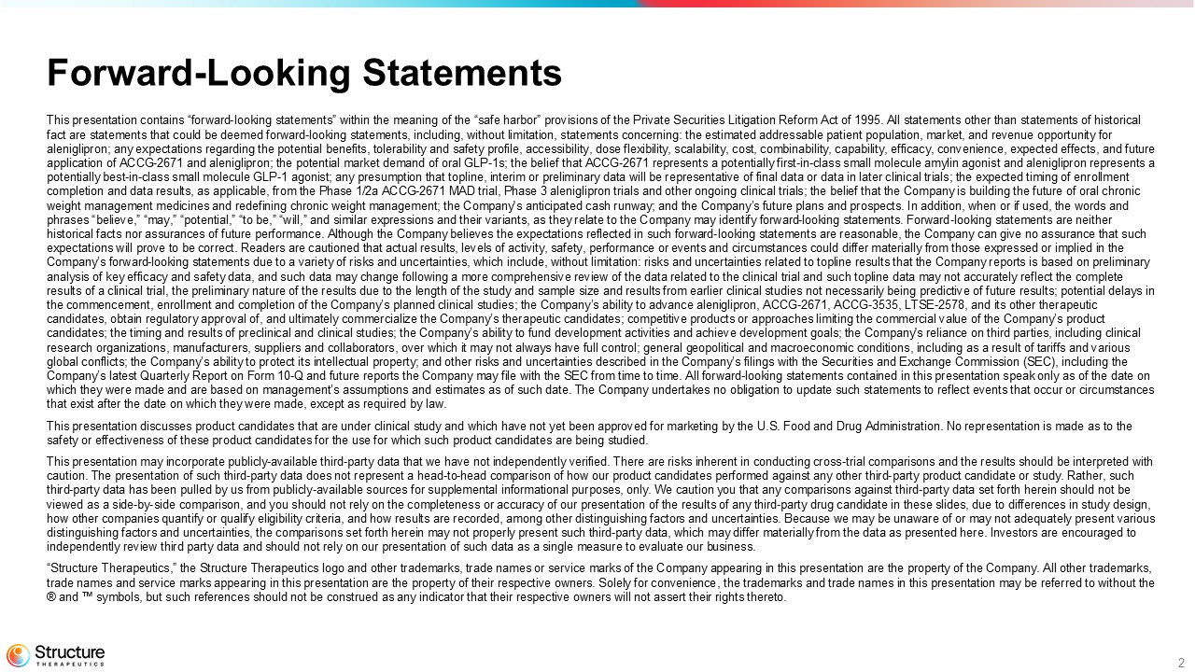
2 This presentation contains “forward - looking statements” within the meaning of the “safe harbor” provisions of the Private Securi ties Litigation Reform Act of 1995. All statements other than statements of historical fact are statements that could be deemed forward - looking statements, including, without limitation, statements concerning: the e stimated addressable patient population, market, and revenue opportunity for aleniglipron; any expectations regarding the potential benefits, tolerability and safety profile, accessibility, dose flexibi lit y, scalability, cost, combinability, capability, efficacy, convenience, expected effects, and future application of ACCG - 2671 and aleniglipron; the potential market demand of oral GLP - 1s; the belief that ACCG - 2671 represents a po tentially first - in - class small molecule amylin agonist and aleniglipron represents a potentially best - in - class small molecule GLP - 1 agonist; any presumption that topline, interim or preliminary data will be repres entative of final data or data in later clinical trials; the expected timing of enrollment completion and data results, as applicable, from the Phase 1/2a ACCG - 2671 MAD trial, Phase 3 aleniglipron trials and other ongoi ng clinical trials; the belief that the Company is building the future of oral chronic weight management medicines and redefining chronic weight management; the Company's anticipated cash runway; and the Company’ s f uture plans and prospects. In addition, when or if used, the words and phrases “believe,” “may,” “potential,” “to be,” “will,” and similar expressions and their variants, as they relate to the Com pan y may identify forward - looking statements. Forward - looking statements are neither historical facts nor assurances of future performance. Although the Company believes the expectations reflected in such forwa rd - looking statements are reasonable, the Company can give no assurance that such expectations will prove to be correct. Readers are cautioned that actual results, levels of activity, safety, performance or eve nts and circumstances could differ materially from those expressed or implied in the Company’s forward - looking statements due to a variety of risks and uncertainties, which include, without limitation: risks and u ncertainties related to topline results that the Company reports is based on preliminary analysis of key efficacy and safety data, and such data may change following a more comprehensive review of the data related to the clinical trial and such topline data may not accurately reflect the complete results of a clinical trial, the preliminary nature of the results due to the length of the study and sample size and results fr om earlier clinical studies not necessarily being predictive of future results; potential delays in the commencement, enrollment and completion of the Company’s planned clinical studies; the Company’s ability to advance aleni gli pron, ACCG - 2671, ACCG - 3535, LTSE - 2578, and its other therapeutic candidates, obtain regulatory approval of, and ultimately commercialize the Company’s therapeutic candidates; competitive pro duc ts or approaches limiting the commercial value of the Company’s product candidates; the timing and results of preclinical and clinical studies; the Company’s ability to fund development activities and achieve development goals; the Company's reliance on third parties, including clinical research organizations, manufacturers, suppliers and collaborators, over which it may not always have full control; general g eop olitical and macroeconomic conditions, including as a result of tariffs and various global conflicts; the Company’s ability to protect its intellectual property; and other risks and uncertainties described in the Company’s filings with the Securities and Exchange Commission (SEC), including the Company’s latest Quarterly Report on Form 10 - Q and future reports the Company may file with the SEC from time to time. All forwa rd - looking statements contained in this presentation speak only as of the date on which they were made and are based on management’s assumptions and estimates as of such date. The Company undertakes no oblig ati on to update such statements to reflect events that occur or circumstances that exist after the date on which they were made, except as required by law. This presentation discusses product candidates that are under clinical study and which have not yet been approved for marketi ng by the U.S. Food and Drug Administration. No representation is made as to the safety or effectiveness of these product candidates for the use for which such product candidates are being studied. This presentation may incorporate publicly - available third - party data that we have not independently verified. There are risks i nherent in conducting cross - trial comparisons and the results should be interpreted with caution. The presentation of such third - party data does not represent a head - to - head comparison of how our product candidates pe rformed against any other third - party product candidate or study. Rather, such third - party data has been pulled by us from publicly - available sources for supplemental informational purposes, only. We caution you that any comparisons against third - party data set forth herein should not be viewed as a side - by - side comparison, and you should not rely on the completeness or accuracy of our presentation of the results of any third - party drug candidate in these slides, due to differences in study design, how other companies quantify or qualify eligibility criteria, and how results are recorded, among other distinguishing factor s a nd uncertainties. Because we may be unaware of or may not adequately present various distinguishing factors and uncertainties, the comparisons set forth herein may not properly present such third - party data, which may differ materially from the data as presented here. Investors are encouraged to independently review third party data and should not rely on our presentation of such data as a single measure to evaluate ou r b usiness. “Structure Therapeutics,” the Structure Therapeutics logo and other trademarks, trade names or service marks of the Company a ppe aring in this presentation are the property of the Company. All other trademarks, trade names and service marks appearing in this presentation are the property of their respective owners. Solely for convenie nce , the trademarks and trade names in this presentation may be referred to without the ® and symbols, but such references should not be construed as any indicator that their respective owners will not assert their righ ts thereto. Forward - Looking Statements

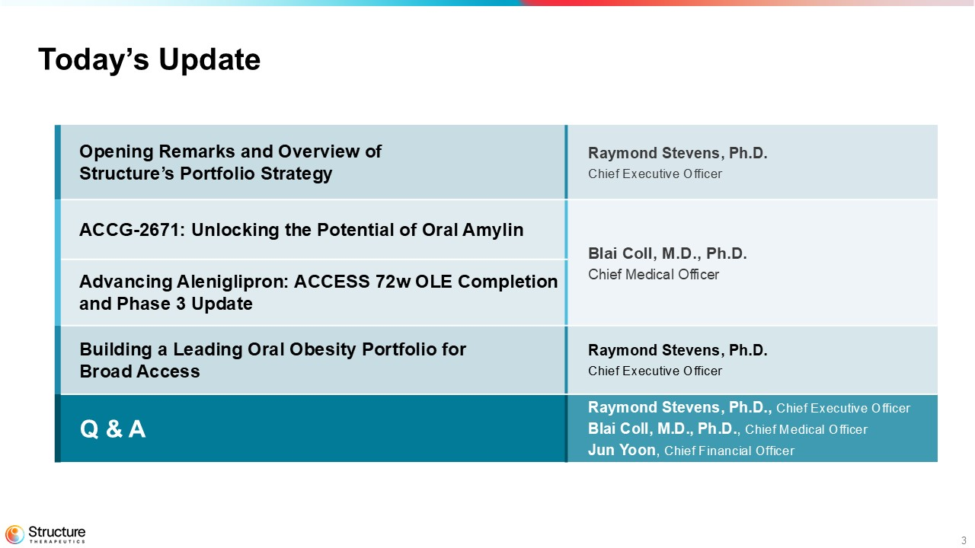
3 Today’s Update Raymond Stevens, Ph.D. Chief Executive Officer Opening Remarks and Overview of Structure’s Portfolio Strategy Blai Coll, M.D., Ph.D. Chief Medical Officer ACCG - 2671: Unlocking the Potential of Oral Amylin Advancing Aleniglipron: ACCESS 72w OLE Completion and Phase 3 Update Raymond Stevens, Ph.D. Chief Executive Officer Building a Leading Oral Obesity Portfolio for Broad Access Raymond Stevens, Ph.D., Chief Executive Officer Blai Coll, M.D., Ph.D. , Chief Medical Officer Jun Yoon , Chief Financial Officer Q & A

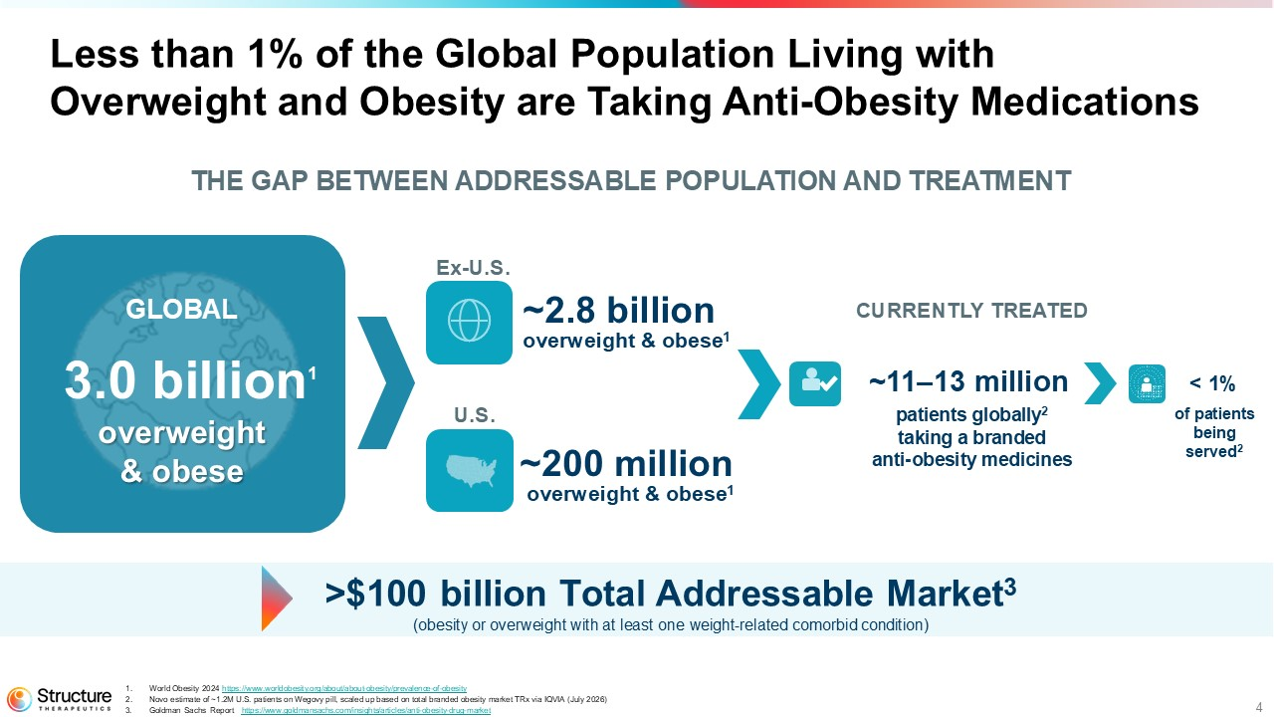
4 Less than 1% of the Global Population Living with Overweight and Obesity are Taking Anti - Obesity Medications CURRENTLY TREATED ~11 – 13 million patients globally 2 taking a branded anti - obesity medicines U.S. ~200 million overweight & obese 1 THE GAP BETWEEN ADDRESSABLE POPULATION AND TREATMENT of patients being served 2 < 1% GLOBAL 3.0 billion 1 overweight & obese >$100 billion Total Addressable Market 3 (obesity or overweight with at least one weight - related comorbid condition ) 1. World Obesity 2024 https:// www.worldobesity.org/about/about - obesity/prevalence - of - obesity 2. Novo estimate of ~1.2M U.S. patients on Wegovy pill, scaled up based on total branded obesity market TRx via IQVIA (July 2026) 3. Goldman Sachs Report https://www.goldmansachs.com/insights/articles/anti - obesity - drug - market Ex - U.S. ~2.8 billion overweight & obese 1

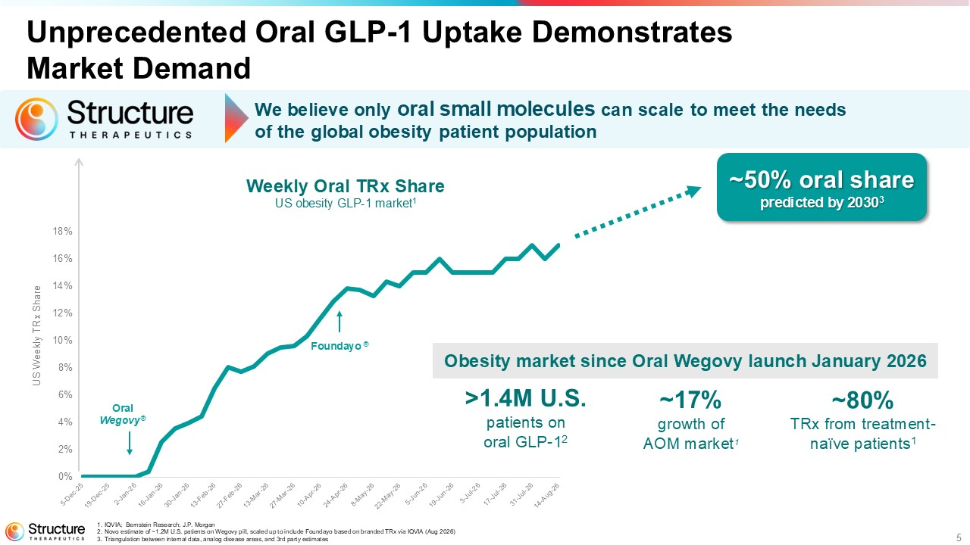
5 Unprecedented Oral GLP - 1 Uptake Demonstrates Market Demand 0% 2% 4% 6% 8% 10% 12% 14% 16% 18% Weekly Oral TRx Share US obesity GLP - 1 market 1 US Weekly TRx Share 1. IQVIA; Bernstein Research; J.P. Morgan 2. Novo estimate of ~1.2M U.S. patients on Wegovy pill, scaled up to include Foundayo based on branded TRx via IQVIA (Aug 2026) 3. Triangulation between internal data, analog disease areas, and 3rd party estimates >1.4M U.S. patients on oral GLP - 1 2 Oral Wegovy ® Foundayo ® ~17% growth of AOM market 1 ~50% oral share predicted by 2030 3 ~80% TRx from treatment - naïve patients 1 Obesity market since Oral Wegovy launch January 2026 We believe only oral small molecules can scale to meet the needs of the global obesity patient population

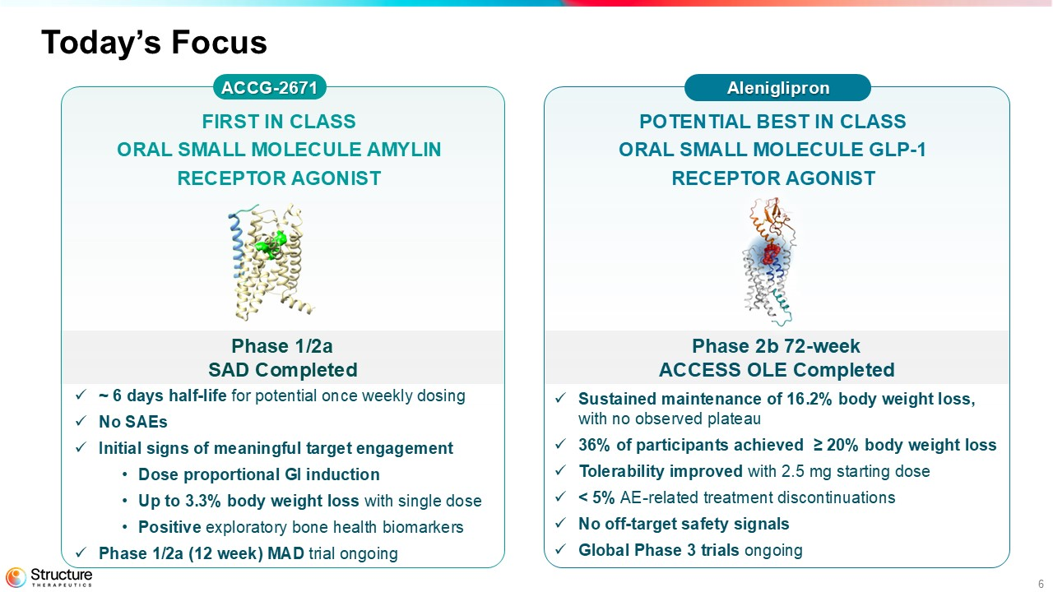
6 Phase 2b 72 - week ACCESS OLE Completed Phase 1/2a SAD Completed Today’s Focus ACCG - 2671 POTENTIAL BEST IN CLASS ORAL SMALL MOLECULE GLP - 1 RECEPTOR AGONIST FIRST IN CLASS ORAL SMALL MOLECULE AMYLIN RECEPTOR AGONIST x ~ 6 days half - life for potential once weekly dosing x No SAEs x Initial signs of meaningful target engagement • Dose proportional GI induction • Up to 3.3% body weight loss with single dose • Positive exploratory bone health biomarkers x Phase 1/2a (12 week) MAD trial ongoing x Sustained maintenance of 16.2% body weight loss, with no observed plateau x 36% of participants achieved ≥ 20% body weight loss x Tolerability improved with 2.5 mg starting dose x < 5% AE - related treatment discontinuations x No off - target safety signals x Global Phase 3 trials ongoing Aleniglipron

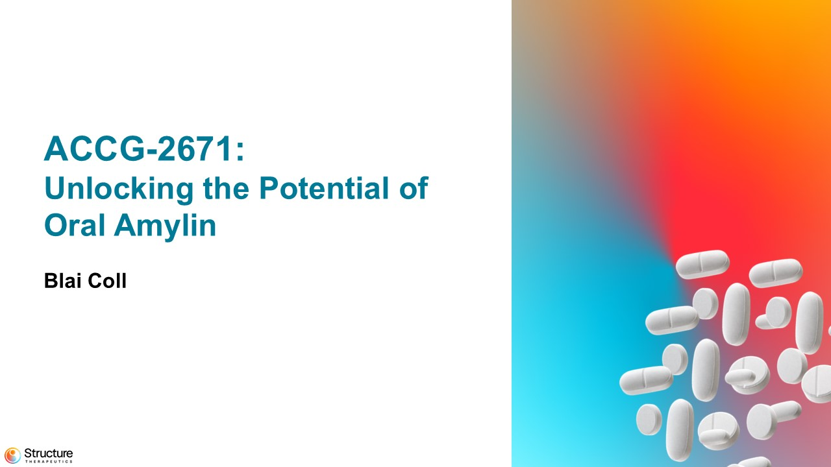
7 ACCG - 2671: Unlocking the Potential of Oral Amylin Blai Coll

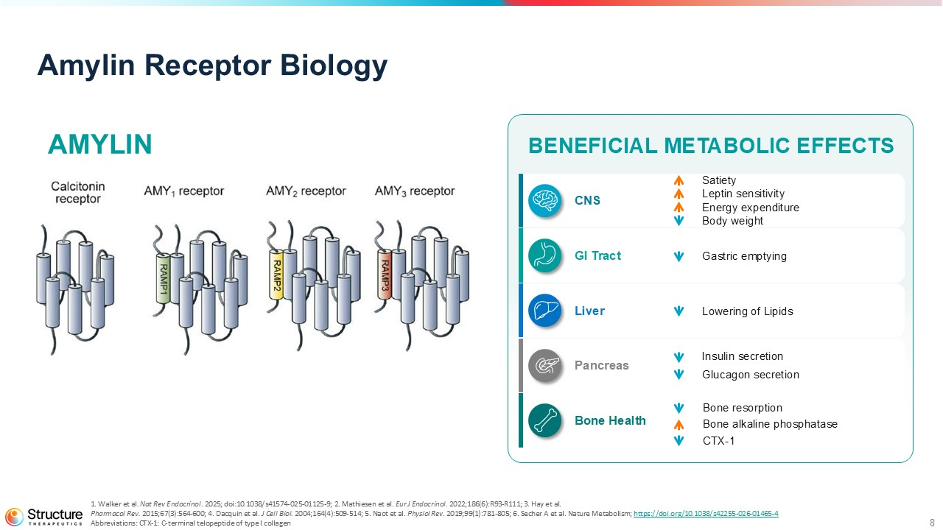
8 Amylin Receptor Biology 1. Walker et al. Nat Rev Endocrinol . 2025; doi:10.1038/s41574 - 025 - 01125 - 9; 2. Mathiesen et al. Eur J Endocrinol. 2022;186(6):R93 - R111; 3. Hay et al. Pharmacol Rev. 2015;67(3):564 - 600; 4. Dacquin et al. J Cell Biol. 2004;164(4):509 - 514; 5. Naot et al. Physiol Rev. 2019;99(1):781 - 805; 6. Secher A et al. Nature Metabolism; https://doi.org/10.1038/s42255 - 026 - 01465 - 4 Abbreviations: CTX - 1: C - terminal telopeptide of type I collagen AMYLIN BENEFICIAL METABOLIC EFFECTS CNS Satiety Leptin sensitivity Energy expenditure Body weight GI Tract Gastric emptying Liver Lowering of Lipids Pancreas Insulin secretion Glucagon secretion Bone Health Bone resorption Bone alkaline phosphatase CTX - 1

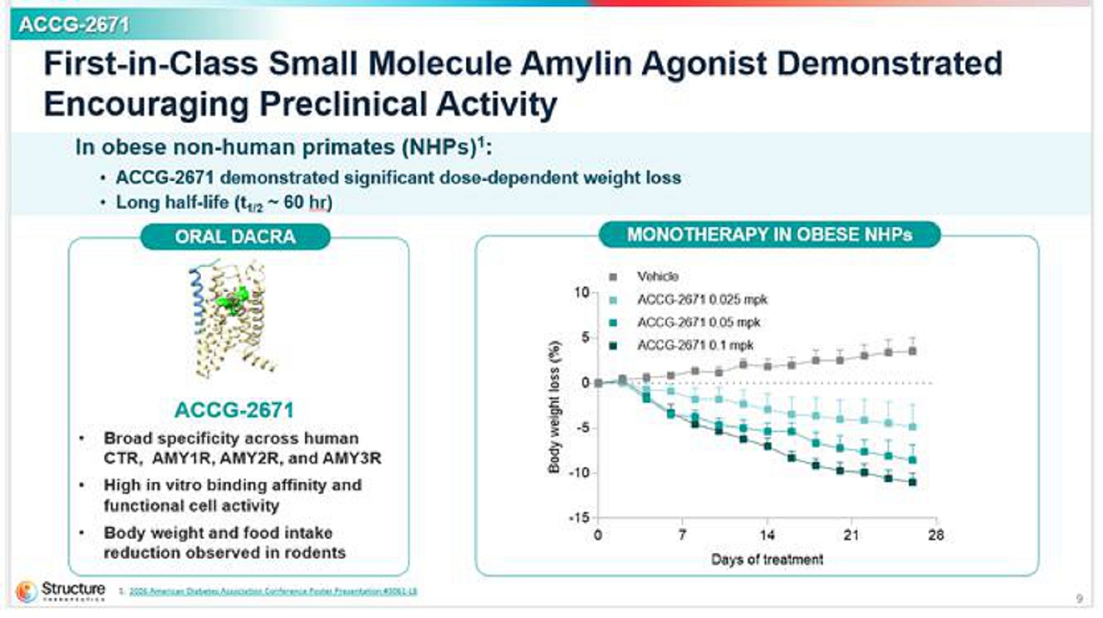
9 ACCG - 2671 First - in - Class Small Molecule Amylin Agonist Demonstrated Encouraging Preclinical Activity 1. 2026 American Diabetes Association Conference Poster Presentation #3061 - LB ORAL DACRA ACCG - 2671 • Broad specificity across human CTR, AMY1R, AMY2R, and AMY3R • High in vitro binding affinity and functional cell activity • Body weight and food intake reduction observed in rodents In obese non - human primates (NHPs) 1 : • ACCG - 2671 demonstrated significant dose - dependent weight loss • Long half - life (t 1/2 ~ 60 hr ) MONOTHERAPY IN OBESE NHPs

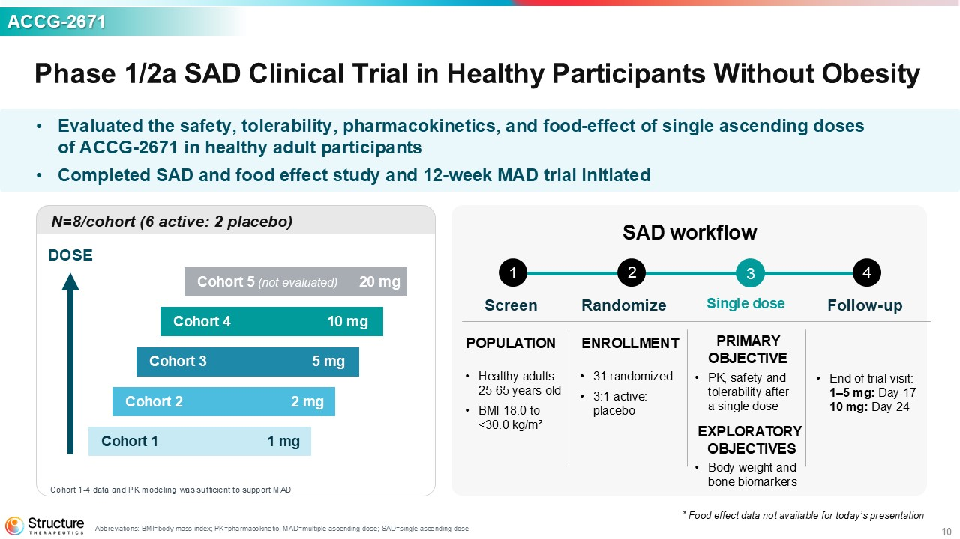
10 Phase 1/2a SAD Clinical Trial in Healthy Participants Without Obesity Abbreviations: BMI=body mass index; PK=pharmacokinetic; MAD=multiple ascending dose; SAD=single ascending dose ACCG - 2671 • Evaluated the safety, tolerability, pharmacokinetics, and food - effect of single ascending doses of ACCG - 2671 in healthy adult participants • Completed SAD and food effect study and 12 - week MAD trial initiated Screen Randomize Single dose Follow - up N=8/cohort (6 active: 2 placebo) DOSE Cohort 1 1 mg Cohort 2 2 mg Cohort 3 5 mg Cohort 4 10 mg Cohort 5 (not evaluated) 20 mg Cohort 1 - 4 data and PK modeling was sufficient to support MAD POPULATION • Healthy adults 25 - 65 years old • BMI 18.0 to <30.0 kg/m² ENROLLMENT • 31 randomized • 3:1 active: placebo PRIMARY OBJECTIVE • PK, safety and tolerability after a single dose • Body weight and bone biomarkers • End of trial visit: 1 – 5 mg: Day 17 10 mg: Day 24 SAD workflow 1 2 3 4 * Food effect d ata not available for today’s presentation EXPLORATORY OBJECTIVES

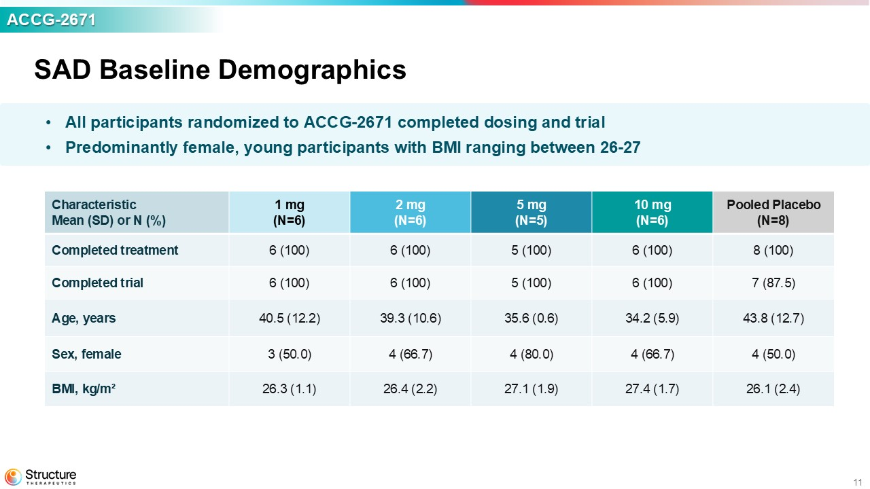
11 ACCG - 2671 SAD Baseline Demographics Pooled Placebo (N=8) 10 mg (N=6) 5 mg (N=5) 2 mg (N=6) 1 mg (N=6) Characteristic Mean (SD) or N (%) 8 (100) 6 (100) 5 (100) 6 (100) 6 (100) Completed treatment 7 (87.5) 6 (100) 5 (100) 6 (100) 6 (100) Completed trial 43.8 (12.7) 34.2 (5.9) 35.6 (0.6) 39.3 (10.6) 40.5 (12.2) Age, years 4 (50.0) 4 (66.7) 4 (80.0) 4 (66.7) 3 (50.0) Sex, female 26.1 (2.4) 27.4 (1.7) 27.1 (1.9) 26.4 (2.2) 26.3 (1.1) BMI, kg/m² • All participants randomized to ACCG - 2671 completed dosing and trial • Predominantly female, young participants with BMI ranging between 26 - 27

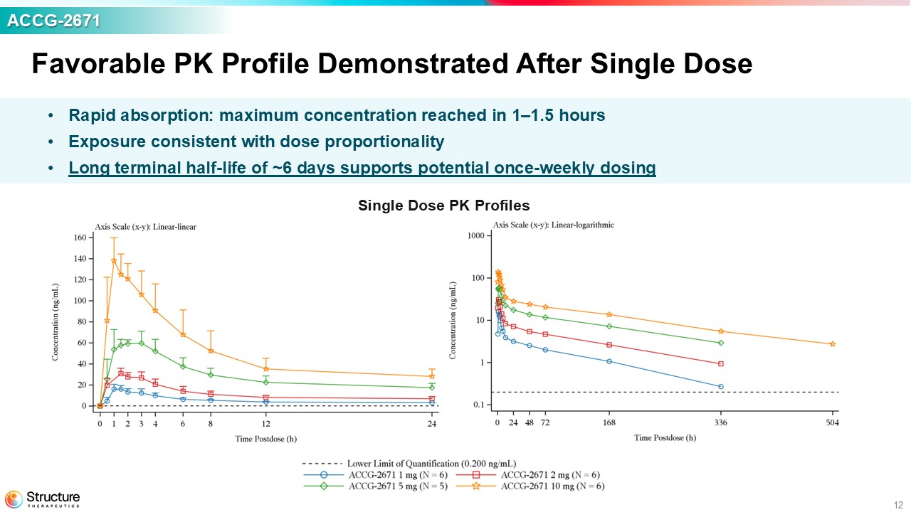
12 Favorable PK Profile Demonstrated After Single Dose Single Dose PK Profiles ACCG - 2671 • Rapid absorption: maximum concentration reached in 1 – 1.5 hours • Exposure consistent with dose proportionality • Long terminal half - life of ~6 days supports potential once - weekly dosing

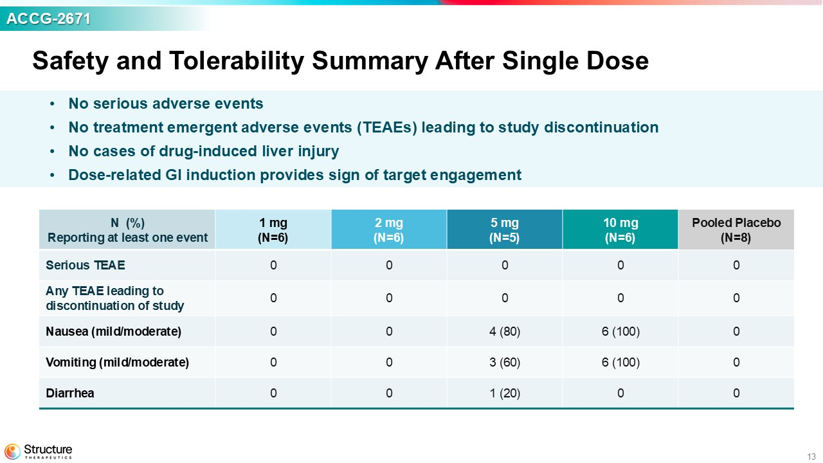
13 Safety and Tolerability Summary After Single Dose ACCG - 2671 • No serious adverse events • No treatment e mergent a dverse e vents (TEAEs) leading to study discontinuation • No cases of drug - induced liver injury • Dose - related GI induction provides sign of target engagement Pooled Placebo (N=8) 10 mg (N=6) 5 mg (N=5) 2 mg (N=6) 1 mg (N=6) N (%) Reporting at least one event 0 0 0 0 0 Serious TEAE 0 0 0 0 0 Any TEAE leading to discontinuation of study 0 6 (100) 4 (80) 0 0 Nausea (mild/moderate) 0 6 (100) 3 (60) 0 0 Vomiting (mild/moderate) 0 0 1 (20) 0 0 Diarrhea

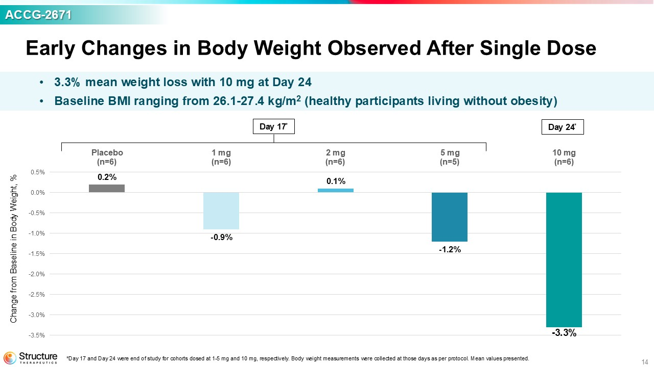
14 ACCG - 2671 Day 17 * 0.2% - 0.9% 0.1% - 1.2% - 3.3% -3.5% -3.0% -2.5% -2.0% -1.5% -1.0% -0.5% 0.0% 0.5% Placebo (n=6) 1 mg (n=6) 2 mg (n=6) 5 mg (n=5) 10 mg (n=6) Day 24 * Change from Baseline in Body Weight, % *Day 17 and Day 24 were end of study for cohorts dosed at 1 - 5 mg and 10 mg, respectively. Body weight measurements were collecte d at those days as per protocol. Mean values presented. • 3.3% mean weight loss with 10 mg at Day 24 • Baseline BMI ranging from 26.1 - 27.4 kg/m 2 (healthy participants living without obesity) Early Changes in Body Weight Observed After Single Dose

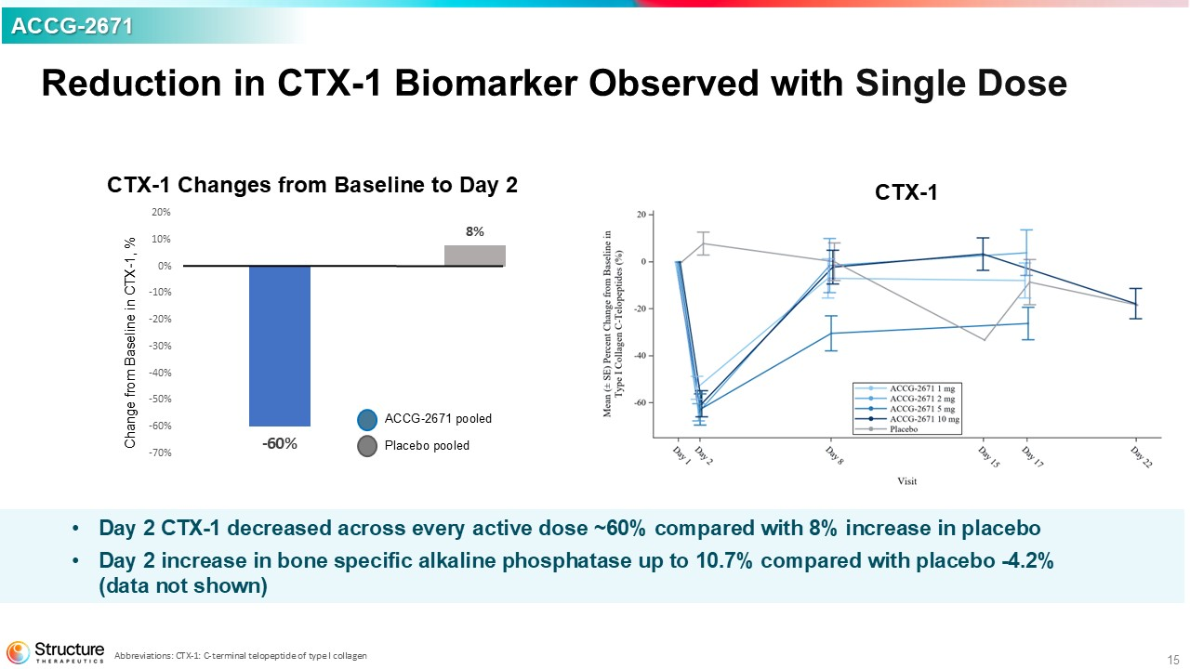
15 • Day 2 CTX - 1 decreased across every active dose ~60% compared with 8% increase in placebo • Day 2 increase in bone specific alkaline phosphatase up to 10.7% compared with placebo - 4.2% (data not shown) CTX - 1 Changes from Baseline to Day 2 CTX - 1 Change from Baseline in CTX - 1, % ACCG - 2671 pooled Placebo pooled - 60% 8% -70% -60% -50% -40% -30% -20% -10% 0% 10% 20% ACCG - 2671 Reduction in CTX - 1 Biomarker Observed with Single Dose Abbreviations: CTX - 1: C - terminal telopeptide of type I collagen

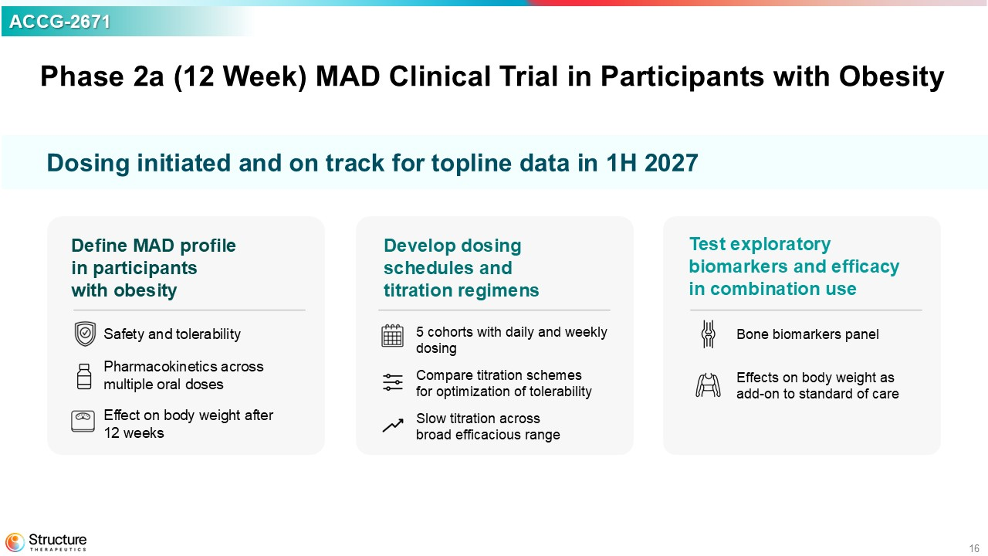
16 Phase 2a (12 Week) MAD Clinical Trial in Participants with Obesity Define MAD profile in participants with obesity Safety and tolerability Pharmacokinetics across multiple oral doses Effect on body weight after 12 weeks Develop dosing schedules and titration regimens 5 cohorts with d aily and weekly dosing Compare titration schemes for optimization of tolerability Slow titration across broad efficacious range Test exploratory biomarkers and efficacy in combination use Bone biomarkers panel Effects on b ody weight as add - on to standard of care ACCG - 2671 Dosing initiated and o n track for topline data in 1H 2027

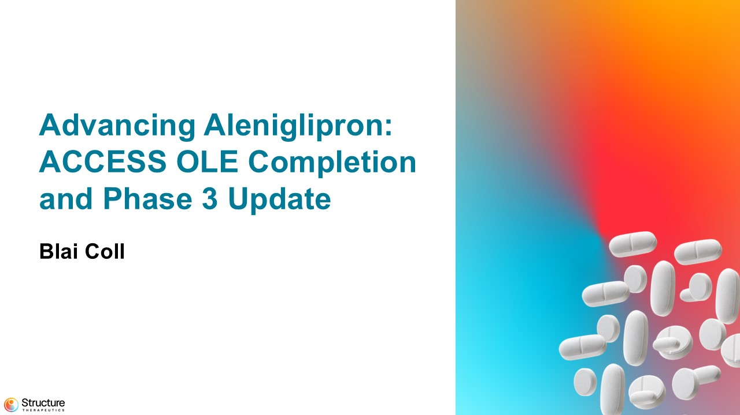
17 Advancing Aleniglipron : ACCESS OLE Completion and Phase 3 Update Blai Coll

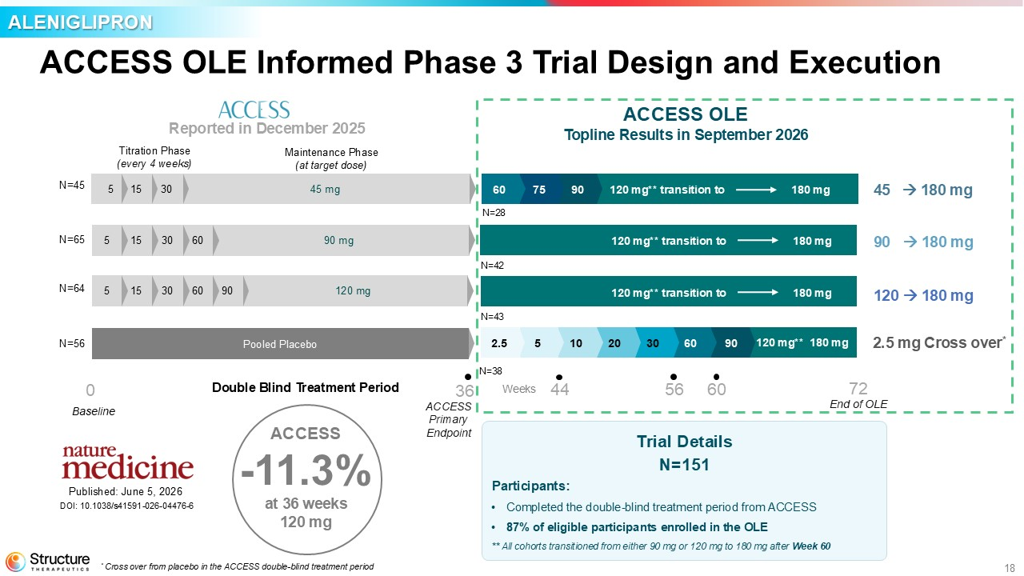
18 ACCESS OLE Informed Phase 3 Trial Design and Execution ALENIGLIPRON ACCESS - 11.3% at 36 weeks 120 mg Baseline Titration Phase (every 4 weeks) Maintenance Phase (at target dose) ACCESS Primary Endpoint 30 15 5 N=45 N=65 N=64 N=56 45 mg 90 mg 60 30 15 5 120 mg 60 30 15 5 90 Pooled Placebo 75 90 60 30 20 10 5 2.5 60 90 End of OLE Trial Details N=151 Participants: • Completed the double - blind treatment period from ACCESS • 87% of eligible participants enrolled in the OLE ** All cohorts transitioned from either 90 mg or 120 mg to 180 mg after Week 60 Double Blind Treatment Period N=28 N=42 N=43 N=38 Weeks 0 36 44 56 72 ACCESS OLE Topline Results in September 2026 Reported in December 2025 180 mg 120 mg** Published: June 5, 2026 DOI: 10.1038/s41591 - 026 - 04476 - 6 60 120 mg** transition to 2.5 mg Cross over * 45 180 mg 90 180 mg 120 180 mg * Cross over from placebo in the ACCESS double - blind treatment period 180 mg 120 mg** transition to 180 mg 120 mg** transition to 180 mg

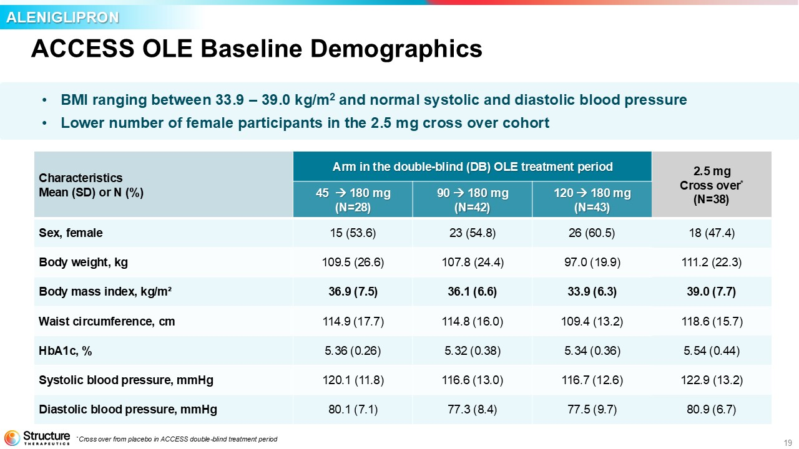
19 ACCESS OLE Baseline Demographics • BMI ranging between 33.9 – 39.0 kg/m 2 and normal systolic and diastolic blood pressure • Lower number of female participants in the 2.5 mg cross over cohort ALENIGLIPRON 2.5 mg Cross over * (N=38) Arm in the double - blind (DB) OLE treatment period Characteristics Mean (SD) or N (%) 120 180 mg (N=43) 90 180 mg (N=42) 45180 mg (N=28) 18 (47.4) 26 (60.5) 23 (54.8) 15 (53.6) Sex, female 111.2 (22.3) 97.0 (19.9) 107.8 (24.4) 109.5 (26.6) Body weight, kg 39.0 (7.7) 33.9 (6.3) 36.1 (6.6) 36.9 (7.5) Body mass index, kg/m² 118.6 (15.7) 109.4 (13.2) 114.8 (16.0) 114.9 (17.7) Waist circumference, cm 5.54 (0.44) 5.34 (0.36) 5.32 (0.38) 5.36 (0.26) HbA1c, % 122.9 (13.2) 116.7 (12.6) 116.6 (13.0) 120.1 (11.8) Systolic blood pressure, mmHg 80.9 (6.7) 77.5 (9.7) 77.3 (8.4) 80.1 (7.1) Diastolic blood pressure, mmHg * Cross over from placebo in ACCESS double - blind treatment period

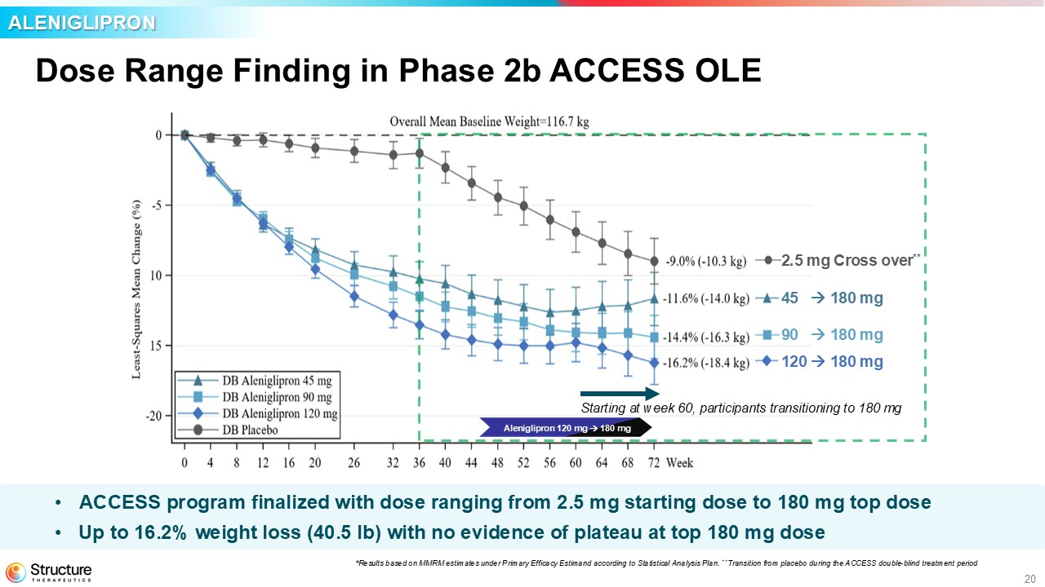
20 • ACCESS program finalized with dose ranging from 2.5 mg starting dose to 180 mg top dose • Up to 16.2% weight loss (40.5 lb ) with no evidence of plateau at top 180 mg dose Dose Range Finding in Phase 2b ACCESS OLE ALENIGLIPRON *Results based on MMRM estimates under Primary Efficacy Estimand according to Statistical Analysis Plan. * * Transition from placebo during the ACCESS double - blind treatment period ACCESS OLE * 2.5 mg Cross over ** 45 180 mg 90 180 mg 120 180 mg Starting at week 60, participants transitioning to 180 mg Aleniglipron 120 mg 180 mg

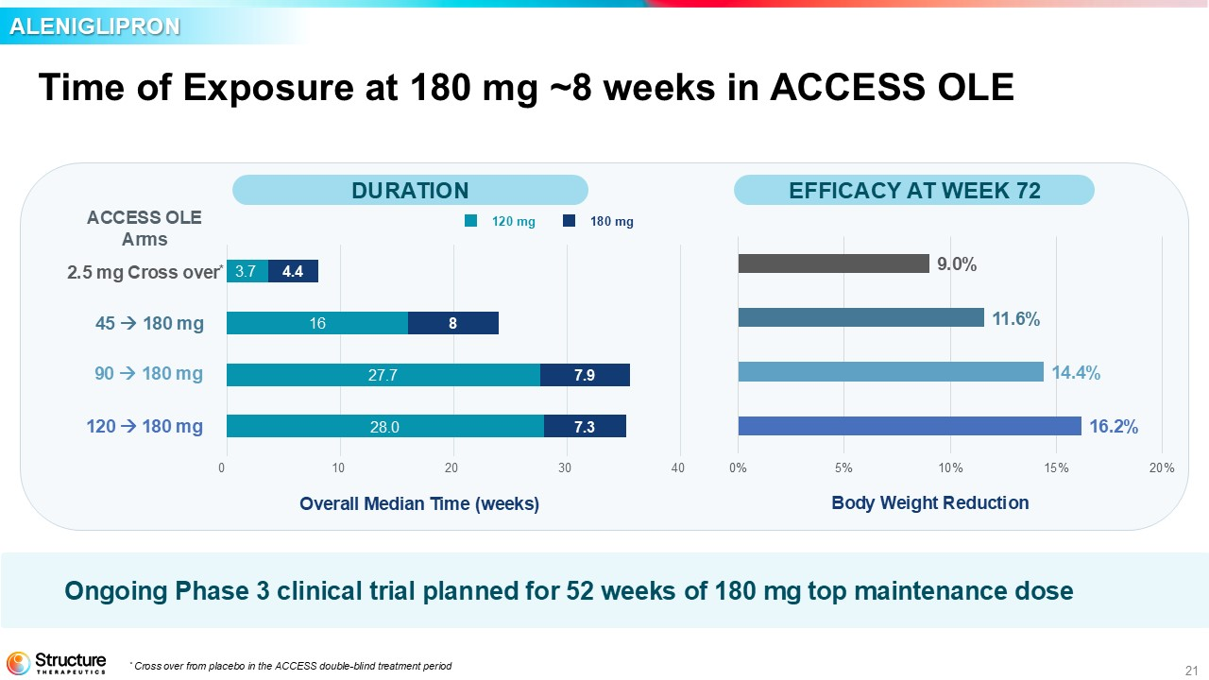
21 Time of Exposure at 180 mg ~8 weeks in ACCESS OLE ACCESS OLE Arms 0 10 20 30 Overall Median T ime ( weeks) 40 120 mg 180 mg 16 8 27.7 7.9 28.0 7.3 3.7 4.4 2.5 mg Cross over * 45 180 mg 90 180 mg 120 180 mg 16.2% 14.4% 11.6% 9.0% 0% 5% 10% 15% 20% Body Weight Reduction * Cross over from placebo in the ACCESS double - blind treatment period ALENIGLIPRON Ongoing Phase 3 clinical trial planned for 52 weeks of 180 mg top maintenance dose DURATION EFFICACY AT WEEK 72

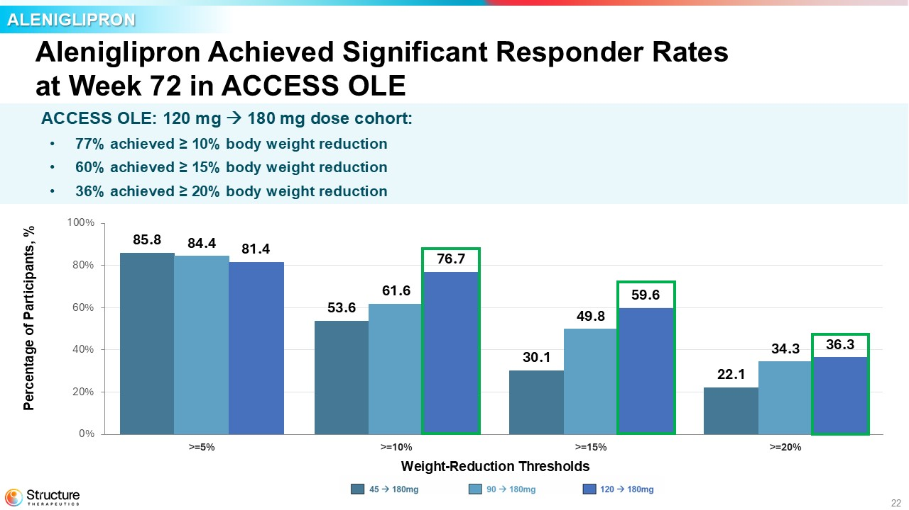
22 Aleniglipron Achieved Significant Responder Rates at Week 72 in ACCESS OLE Percentage of Participants, % ALENIGLIPRON 85.8 53.6 30.1 22.1 84.4 61.6 49.8 34.3 81.4 76.7 59.6 36.3 0% 20% 40% 60% 80% 100% >=5% >=10% >=15% >=20% Weight - Reduction Thresholds DB 45 mg DB 90 mg DB 120 mg 90 180mg 120 180mg 2.5mg Cross over ACCESS OLE: 120 mg 180 mg dose cohort: • 77% achieved ≥ 10% body weight reduction • 60% achieved ≥ 15% body weight reduction • 36% achieved ≥ 20% body weight reduction

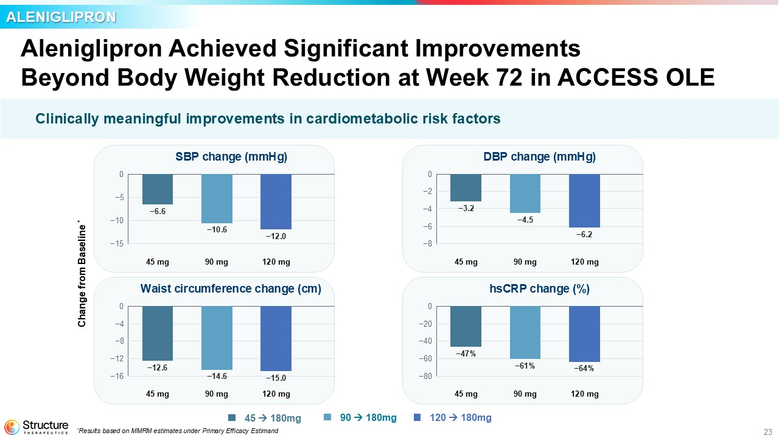
23 Aleniglipron Achieved Significant Improvements Beyond Body Weight Reduction at Week 72 in ACCESS OLE ALENIGLIPRON 45 180mg 90 180mg 120 180mg Clinically meaningful improvements in cardiometabolic risk factors * Results based on MMRM estimates under Primary Efficacy Estimand Change from Baseline * SBP change (mmHg) 0 −5 −10 −15 −6.6 45 mg −10.6 90 mg −12.0 120 mg DBP change (mmHg) 0 −2 −4 −6 −8 −3.2 45 mg −4.5 90 mg −6.2 120 mg Waist circumference change (cm) 0 −4 −8 −12 −16 −12.6 45 mg −14.6 90 mg −15.0 120 mg hsCRP change (%) 0 −20 −40 −60 −80 −47% 45 mg −61% 90 mg −64% 120 mg

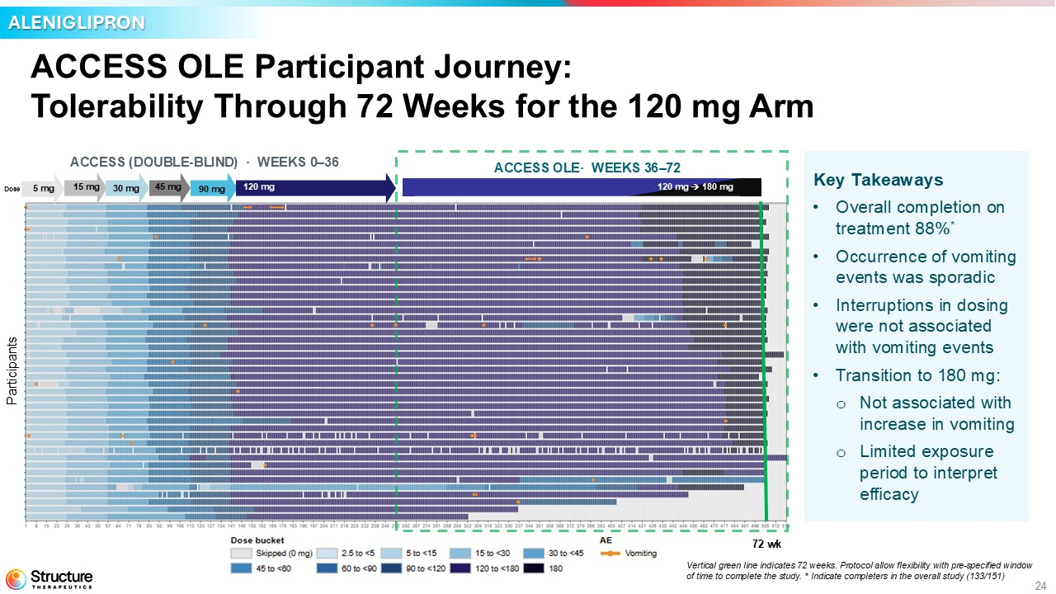
24 ACCESS ( DOUBLE - BLIND ) · WEEKS 0 – 36 ACCESS OLE · WEEKS 36 – 72 5 mg 15 mg 30 mg 45 mg Dose 90 mg 120 mg ACCESS OLE Participant Journey: Tolerability Through 72 Weeks for the 120 mg Arm ALENIGLIPRON Participants 120 mg 180 mg 72 wk Vertical green line indicates 72 weeks. Protocol allow flexibility with pre - specified window of time to complete the study. * Indicate completers in the overall study (133/151) Key Takeaways • Overall completion on treatment 88% * • Occurrence of vomiting events was sporadic • Interruptions in dosing were not associated with vomiting events • Transition to 180 mg: o Not associated with increase in vomiting o Limited exposure period to interpret efficacy

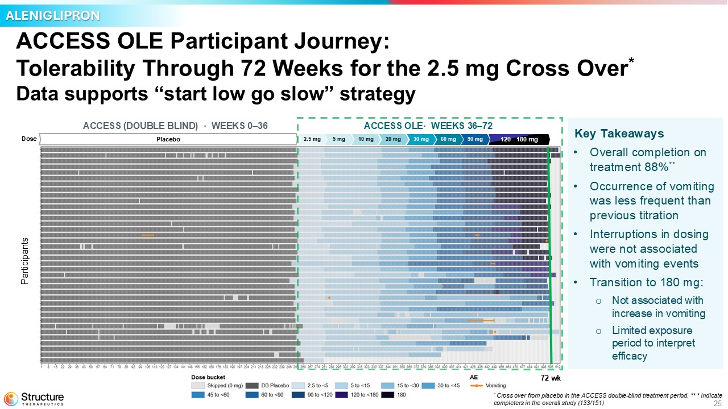
25 ACCESS OLE Participant Journey: Tolerability Through 72 Weeks for the 2.5 mg Cross Over * Data supports “start low go slow” strategy ACCESS (DOUBLE BLIND) · WEEKS 0 – 36 ACCESS OLE· WEEKS 36 – 72 Placebo 2.5 mg 5 mg 10 mg 20 mg 30 mg 60 mg 90 mg 120 - 180 mg Dose ALENIGLIPRON Participants * Cross over from placebo in the ACCESS double - blind treatment period. ** * Indicate completers in the overall study (133/151) 72 wk Key Takeaways • Overall completion on treatment 88% ** • Occurrence of vomiting was less frequent than previous titration • Interruptions in dosing were not associated with vomiting events • Transition to 180 mg: o Not associated with increase in vomiting o Limited exposure period to interpret efficacy

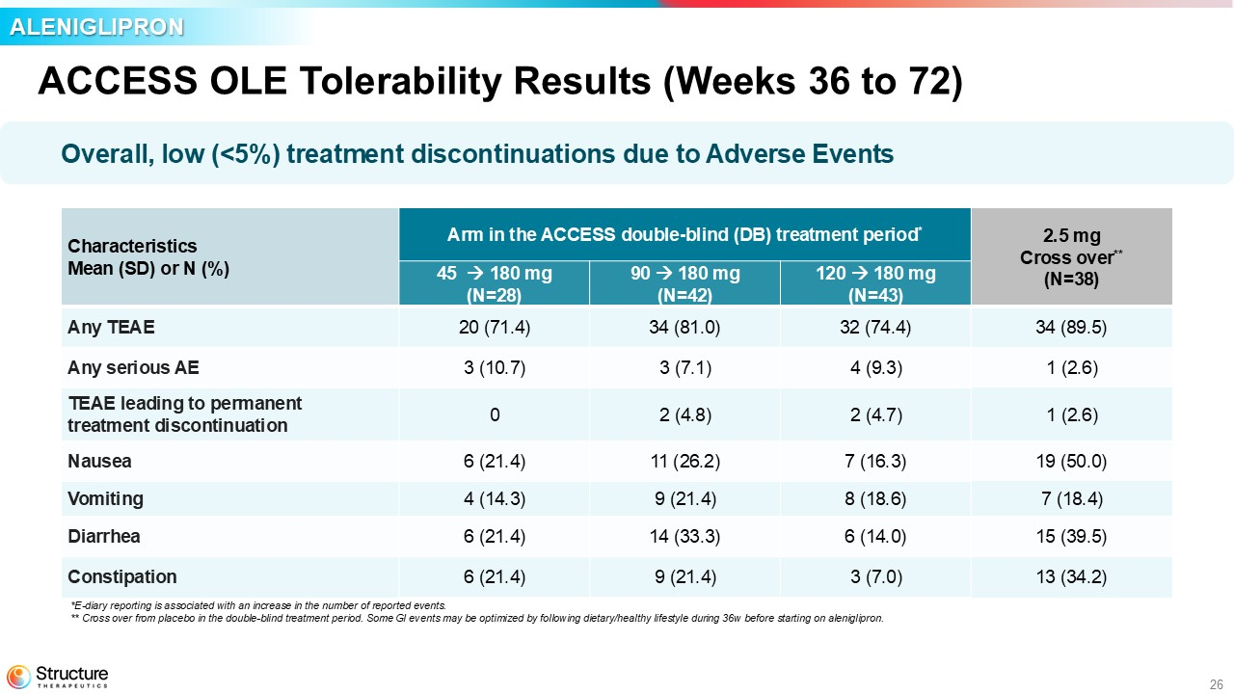
26 ACCESS OLE Tolerability Results (Weeks 36 to 72) Overall, low (<5%) treatment discontinuations due to Adverse Events *E - diary reporting is associated with an increase in the number of reported events. ** Cross over from placebo in the double - blind treatment period. Some GI events may be optimized by following dietary/healthy lifestyle during 36w before starting on aleniglipron. ALENIGLIPRON 2.5 mg Cross over ** (N=38) Arm in the ACCESS double - blind (DB) treatment period * Characteristics Mean (SD) or N (%) 120 180 mg (N=43) 90 180 mg (N=42) 45 180 mg (N=28) 34 (89.5) 32 (74.4) 34 (81.0) 20 (71.4) Any TEAE 1 (2.6) 4 (9.3) 3 (7.1) 3 (10.7) Any serious AE 1 (2.6) 2 (4.7) 2 (4.8) 0 TEAE leading to permanent treatment discontinuation 19 (50.0) 7 (16.3) 11 (26.2) 6 (21.4) Nausea 7 (18.4) 8 (18.6) 9 (21.4) 4 (14.3) Vomiting 15 (39.5) 6 (14.0) 14 (33.3) 6 (21.4) Diarrhea 13 (34.2) 3 (7.0) 9 (21.4) 6 (21.4) Constipation

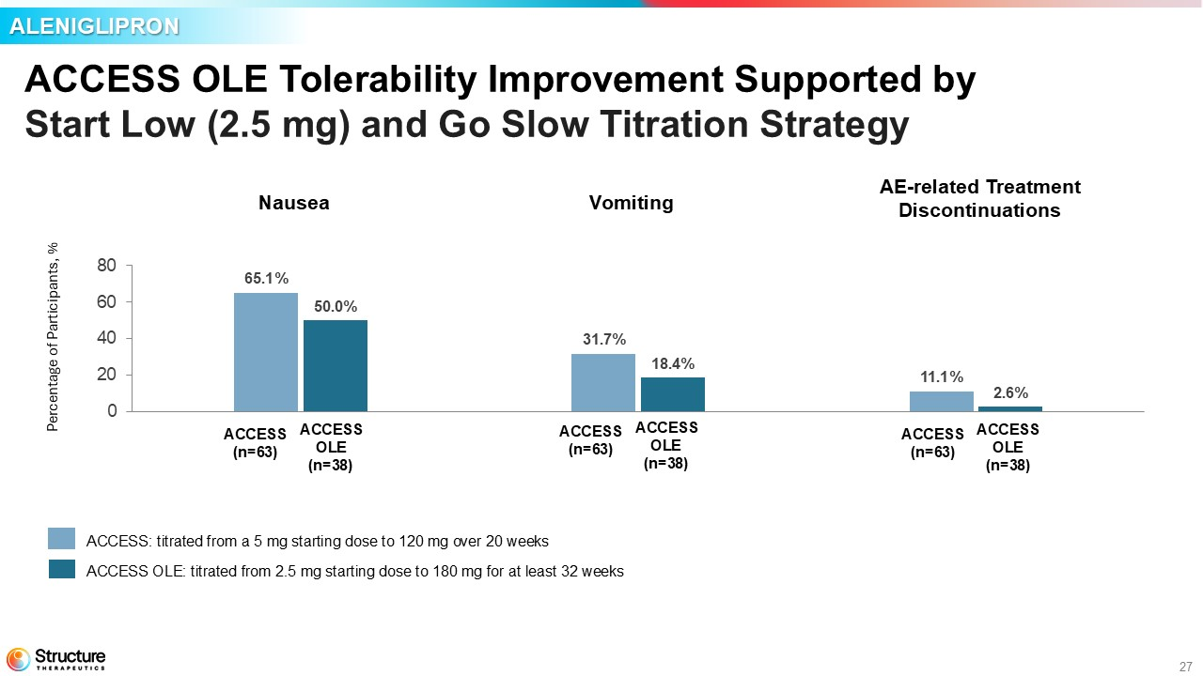
27 ACCESS OLE Tolerability Improvement Supported by Start Low (2.5 mg) and Go Slow Titration Strategy 65.1 % 31.7 % 11.1 % 50.0 % 18.4 % 2.6 % 0 20 40 60 80 Nausea Vomiting TEAE-led discontinuation 120 mg, Weeks 0 – 36 (N=63) DB Placebo → 180 mg, Weeks 36 – 72 (N=38) Percentage of Participants, % ALENIGLIPRON ACCESS (n=63) ACCESS OLE (n=38) ACCESS (n=63) ACCESS OLE (n=38) ACCESS (n=63) ACCESS OLE (n=38) ACCESS: titrated from a 5 mg starting dose to 120 mg over 20 weeks ACCESS OLE: titrated from 2.5 mg starting dose to 180 mg for at least 32 weeks Nausea Vomiting AE - related Treatment Discontinuations

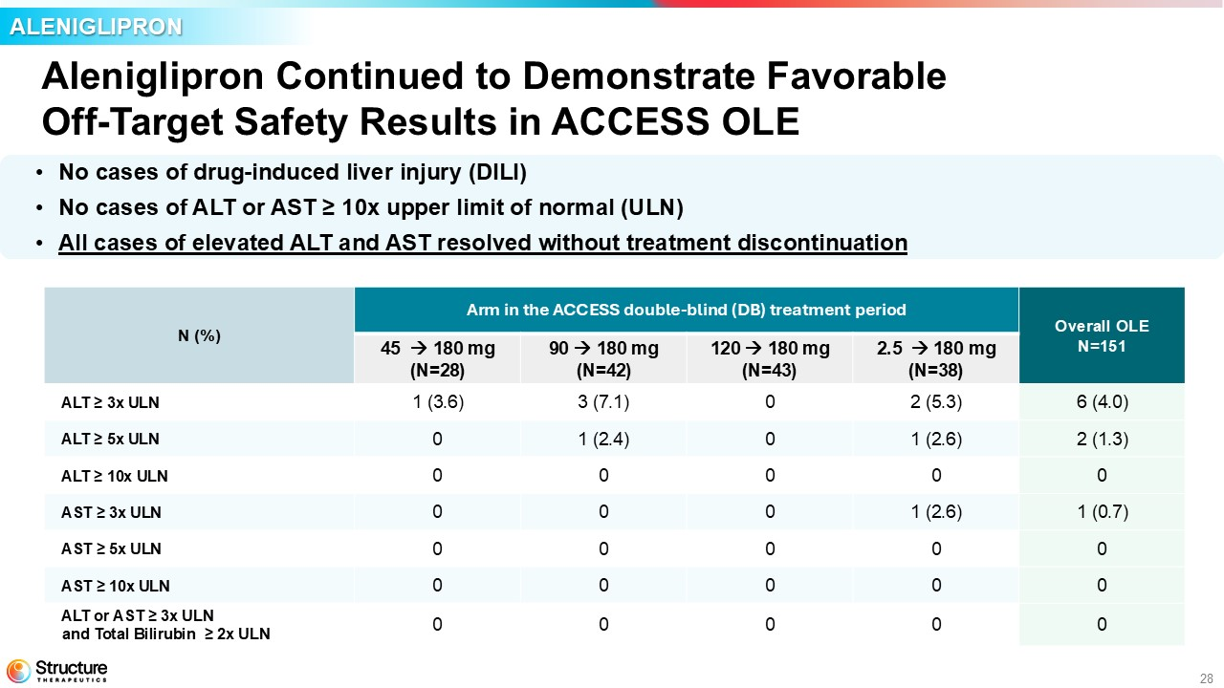
28 Aleniglipron Continued to Demonstrate Favorable Off - Target Safety Results in ACCESS OLE • No cases of drug - induced liver injury (DILI) • No cases of ALT or AST ≥ 10x upper limit of normal (ULN) • All cases of elevated ALT and AST resolved without treatment discontinuation ALENIGLIPRON Overall OLE N=151 Arm in the ACCESS double - blind (DB) treatment period N (%) 2.5 180 mg (N=38) 120 180 mg (N=43) 90 180 mg (N=42) 45 180 mg (N=28) 6 (4.0) 2 (5.3) 0 3 (7.1) 1 (3.6) ALT ≥ 3x ULN 2 (1.3) 1 (2.6) 0 1 (2.4) 0 ALT ≥ 5x ULN 0 0 0 0 0 ALT ≥ 10x ULN 1 (0.7) 1 (2.6) 0 0 0 AST ≥ 3x ULN 0 0 0 0 0 AST ≥ 5x ULN 0 0 0 0 0 AST ≥ 10x ULN 0 0 0 0 0 ALT or AST ≥ 3x ULN and Total Bilirubin ≥ 2x ULN

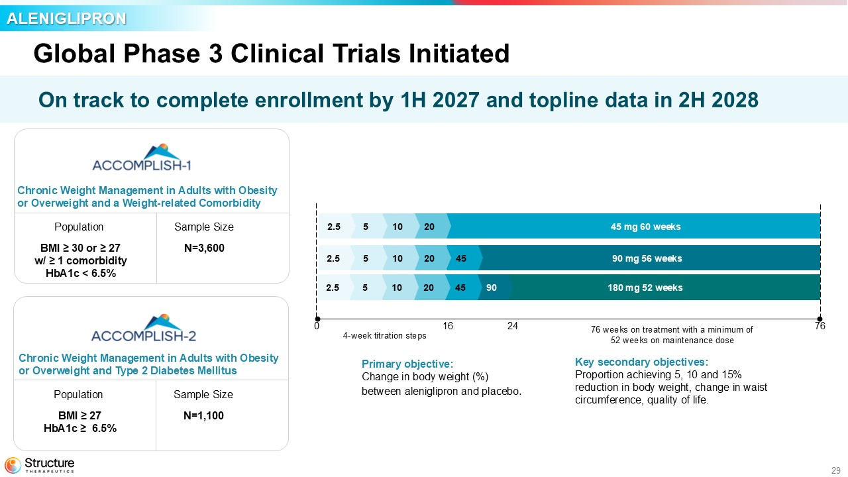
29 Global Phase 3 Clinical Trials Initiated Chronic Weight Management in Adults with Obesity or Overweight and a Weight - related Comorbidity Population Sample Size BMI ≥ 30 or ≥ 27 w/ ≥ 1 comorbidity HbA1c < 6.5% N=3,600 Chronic Weight Management in Adults with Obesity or Overweight and Type 2 Diabetes Mellitus Population Sample Size BMI ≥ 27 HbA1c ≥ 6.5% N=1,100 4 - week titration steps 180 mg 52 weeks 90 45 20 10 5 2.5 90 mg 56 weeks 45 20 10 5 2.5 45 mg 60 weeks 20 10 5 2.5 0 16 24 76 76 weeks on treatment with a minimum of 52 weeks on maintenance dose Key secondary objectives: Proportion achieving 5, 10 and 15% reduction in body weight, change in waist circumference, quality of life. Primary objective: Change in body weight (%) between aleniglipron and placebo . ALENIGLIPRON On track to complete enrollment by 1H 2027 and topline data in 2H 2028

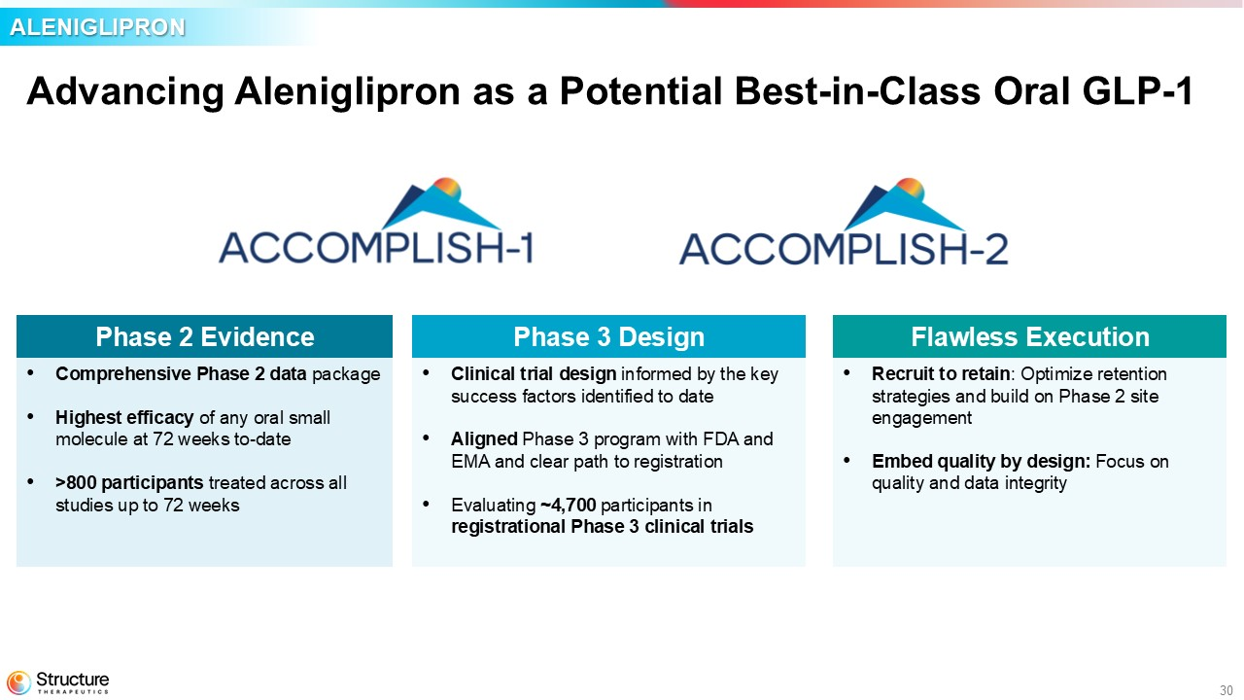
30 Advancing Aleniglipron as a Potential Best - in - Class Oral GLP - 1 Phase 3 Design • Clinical trial design informed by the key success factors identified to date • Aligned Phase 3 program with FDA and EMA and clear path to registration • Evaluating ~4,700 participants in registrational Phase 3 clinical trials Phase 2 Evidence • Comprehensive Phase 2 data package • Highest efficacy of any oral small molecule at 72 weeks to - date • >800 participants treated across all studies up to 72 weeks ALENIGLIPRON Flawless Execution • Recruit to retain : Optimize retention strategies and build on Phase 2 site engagement • Embed quality by design: Focus on quality and data integrity

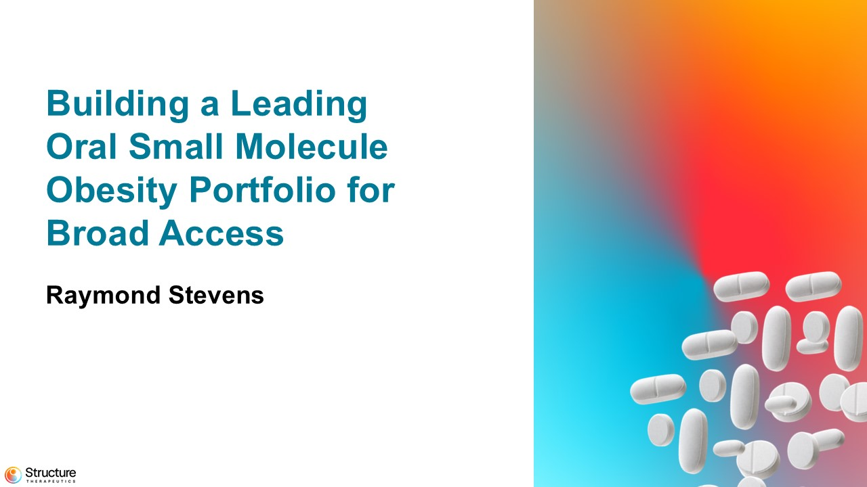
31 Building a Leading Oral Small Molecule Obesity Portfolio for Broad Access Raymond Stevens

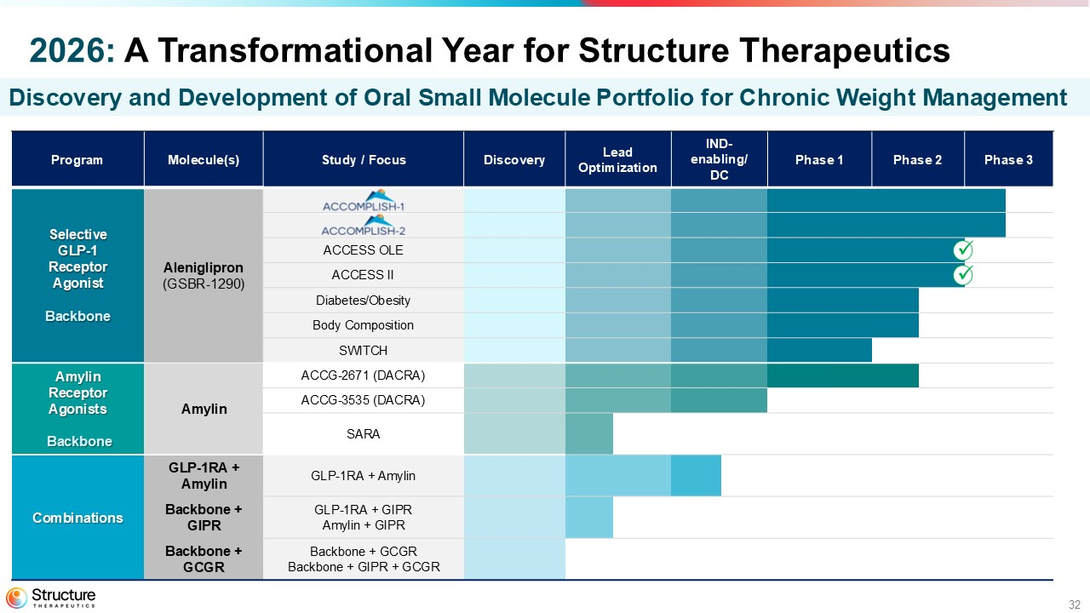
32 Phase 3 Phase 2 Phase 1 IND - enabling/ DC Lead Optimization Discovery Study / Focus Molecule(s) Program Aleniglipron (GSBR - 1290) Selective GLP - 1 Receptor Agonist Backbone ACCESS OLE ACCESS II Diabetes/Obesity Body Composition SWITCH ACCG - 2671 (DACRA) Amylin Amylin Receptor Agonists Backbone ACCG - 3535 (DACRA) SARA GLP - 1RA + Amylin GLP - 1RA + Amylin Combinations GLP - 1RA + GIPR Amylin + GIPR Backbone + GIPR Backbone + GCGR Backbone + GIPR + GCGR Backbone + GCGR 2026: A Transformational Year for Structure Therapeutics Discovery and Development of Oral Small Molecule Portfolio for Chronic Weight Management

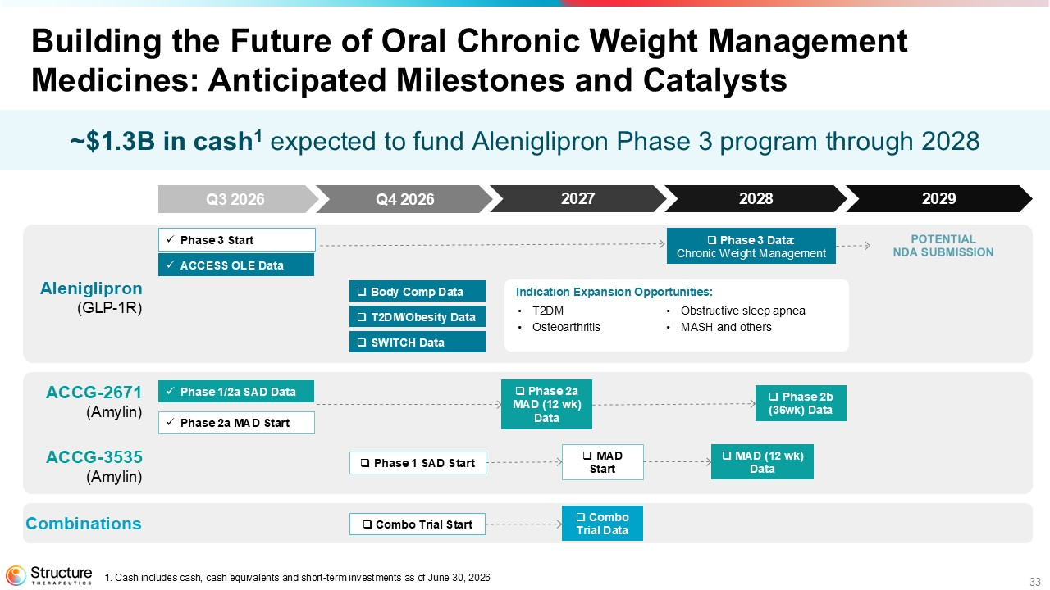
33 1. Cash includes cash, cash equivalents and short - term investments as of June 30, 2026 2028 2027 2029 x Phase 3 Start x ACCESS OLE Data □ Body Comp Data □ T2DM/Obesity Data □ SWITCH Data x Phase 1/2a SAD Data □ Phase 2a MAD (12 wk ) Data □ Phase 2b (36wk) Data □ Phase 1 SAD Start □ Combo Trial Start □ MAD (12 wk ) Data x Phase 2a MAD Start □ MAD Start □ Combo Trial Data Indication Expansion Opportunities: • T2DM • Osteoarthritis • Obstructive sleep apnea • MASH and others ~$1.3B in cash 1 expected to fund Aleniglipron Phase 3 program through 2028 Aleniglipron (GLP - 1R) ACCG - 2671 (Amylin) ACCG - 3535 (Amylin) Combinations □ Phase 3 Data: Chronic Weight Management Building the Future of Oral Chronic Weight Management Medicines: Anticipated Milestones and Catalysts Q3 2026 Q4 2026

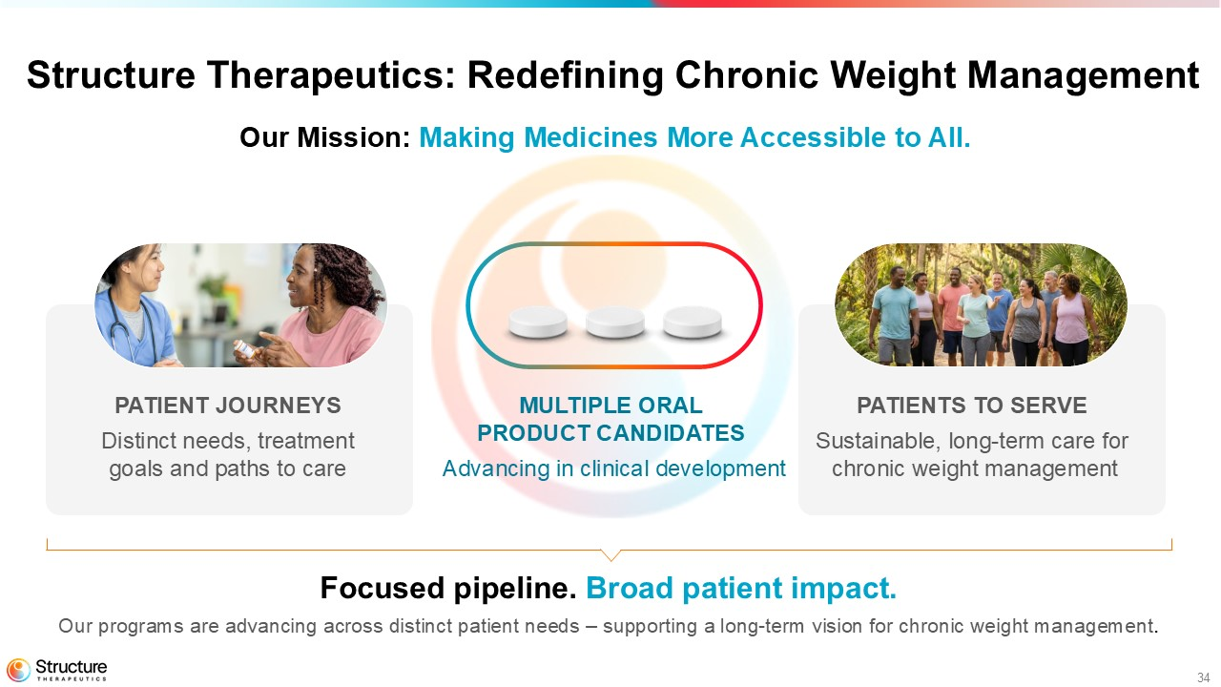
34 Structure Therapeutics: Redefining Chronic Weight Management Our Mission: Making Medicines More Accessible to All. Focused pipeline. Broad patient impact. Our programs are advancing across distinct patient needs – supporting a long - term vision for chronic weight management . MULTIPLE ORAL PRODUCT CANDIDATES Advancing in clinical development PATIENT JOURNEYS Distinct needs, treatment goals and paths to care PATIENTS TO SERVE S ustainable, long - term care for chronic weight management


35 Q&A

